Women’s Honour Roll 2012

Recipients:
- Susan Maree Waters
- Valmai Heap (Posthumous)

Susan Maree Waters
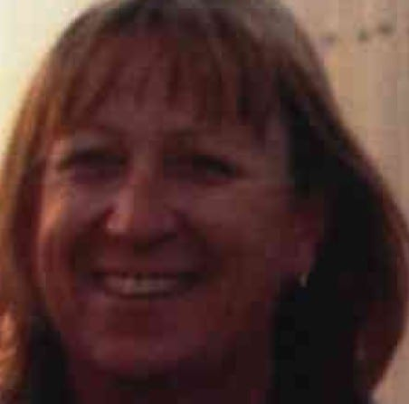
Sue Waters has lived in Spargo Creek and worked in the Hepburn Shire for eleven years, both as a volunteer and in paid work. Sue has been with the Leonards Hill Fire Brigade for eleven years and became 1st Lieutenant before being elected Captain for five years—the first female Captain of the Brigade. On stepping down as Captain, she is now 2nd Lieutenant in a training officer’s position. She has also been a volunteer with the SES for two years. After three months she was made a team leader, a position she now holds through her voluntary work.

Sue has played important roles in enabling these organisations to provide their vital services to the community. In taking on the leadership roles she has filled in the once male-dominated organisations of the CFA and SES. Sue has been a powerful and successful role model for local women to follow. She has thus assisted in opening up service in these organisations to other women, helping to break down the stereotypical perception amongst men and women of what a woman’s role as a volunteer in a rural Shire should be.

She has also worked at Littles as a bus driver for the past ten and a half years, being the only female bus driver for about the first six years. In being a female bus driver, she has also been a role model for others to follow into previously male- dominated paid work. Some years ago, Sue encouraged another woman to apply and she is now a bus driver with Littles. Sue has been a member of the Korweinguboora Recreations Reserve Committee. She was also a first aid volunteer for the Daylesford football and netball players for three years. In her personal life, Sue and her husband have created a truly equal partnership, sharing all parenting tasks and domestic chores, including cooking—a women’s liberation dream—and a situation which has enabled her, as a woman with a growing family, to make her own unique contribution to life outside the home.

Valmai Heap (Posthumous)
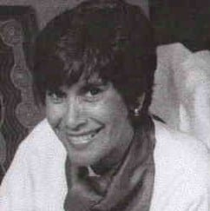
In 1983 Valmai Heap of the Yorta Yorta people became the first woman appointed as CEO of the Ballarat and District Aboriginal Cooperative (B&DAC;). Her appointment constituted a significant advancement in the status of women. It affirmed women’s entitlement to hold a level of office once the preserve of males and (given an all-male board of directors as the appointing body) demonstrated male recognition of women’s abilities to handle diverse organisational demands in adverse circumstances.

Importantly, it meant greater inclusion of women in shaping their community’s development, and inspired them to dream of, and reach for, opportunities previously denied them. Valmai’s leadership strength lay in her ability to listen and communicate. She understood the importance of consultation to good leadership. This allowed her to act as a conduit for identifying social and cultural issues important to both effective workplace relations and bearing on the direction of the cooperative’s development. She gave support and identified opportunities for women. Valmai led through compassion and by example, but also through practical action on the issues of Koorie culture and education, and domestic violence. Valmai initiated and developed opportunities to reconnect with traditional skills and culture, to become effective Koori educators, and to access effective support for domestic violence victims.

Valmai’s appointment as CEO opened the way for a fresh approach to issues detrimental to both workplace relations and the daily life of the Co-op’s clientele; issues either submerged due to disregard (e.g. women’s health and domestic violence) or seen as the province of women in traditional culture (e.g. educating the young). Increased permission and space to address such issues arguably disposed to significant benefits for the individual women involved in the Co-op (as direct participants or as clients) and their families. Such is the basis for building personal and collective confidence, and valuable social capital that benefits everyone. She worked closely with the Victorian Aboriginal Health Service, raising awareness of women’s health issues, and identified opportunities for women to develop as artists. The change heralded by Valmai’s pioneering steps as the first woman CEO in B&DAC; is confirmed in the composition of today’s B&DAC; Board of Directors: four women and three men directors. Her efforts to promote Koori culture, education and access to support for domestic violence victims—while rudimentary—can be seen as seeds for the expanded range of services offered by B&DAC; today. Originally established to provide services in health, welfare and housing, its services now include art, culture, education, and social wellbeing. Valmai’s legacy entwines with the fruitful efforts of the many who shared and nurtured the vision of a better future for her community and culture. The Val Heap Trust fund is part of that legacy. Valmai’s contributions in regards to contributing creative, unique or innovative ideas and initiatives are best apprehended in her cultural heritage work. In 1988 she became the first Koori appointed by Museum Victoria: the inaugural position of Coordinator, aboriginal Training. In this role Valmai initiated projects and strategies which effectively promoted recognition of the role of women and shaped opinion within the Victorian Aboriginal community and beyond. It was Valmai’s dream that a “Keeping Place” (museum) should be established in Ballarat. This was eventually done and owes a debt to Valmai.

