Women’s Honour Roll 2014

Recipients:
- Elizabeth Hepburn (Posthumous)

Elizabeth Hepburn (Posthumous)
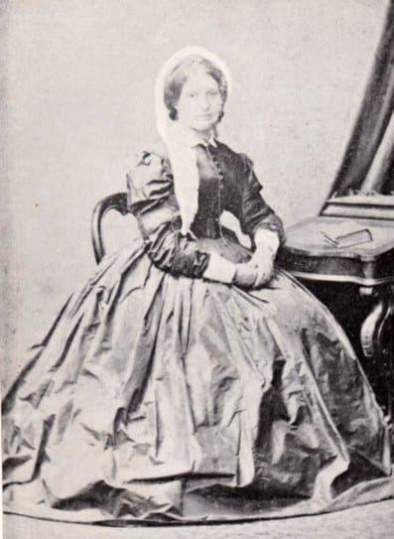
Born in 1805 Elizabeth Combes (Hepburn) was the child of Thomas and Anne Combes. She was baptised at the parish church of Cowley, and on 17 May 1830 at the age of 25 (or 24) married John Hepburn at St Anne, Limehouse.

An opportunity was presented to Hepburn to captain a steamship between Sydney and the Hunter River in New South Wales which he eagerly took up. Elizabeth Hepburn travelled from London to Australia in 1837. Elizabeth Hepburn did the trip from London to Sydney with two young children.

They travelled for three long months from the settled districts of New South Wales to the area now called Smeaton where they settled.

More than just the first white woman in the district, Elizabeth Hepburn played an important role in the establishment of a farming community in the Hepburn district. Elizabeth Hepburn also took a special interest in the welfare of aboriginal women.

As a woman with pioneering experience she would have played an important role as a mentor and friend. Her presence in the male dominated squattocracy would have been welcomed by many, but most especially by the women who settled in the district.

