Women’s Honour Roll 2017

Recipients:
- Kit Manning
- Jenny Beacham
- Candy Broad
- Elsie Miller

Kit Manning
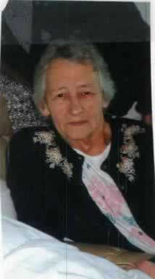
“The individual contribution Kit makes Trentham and its facilities, can be best measured by the high personal esteem she carries in the community but the biggest reward for Kit is being able to witness other people’s happiness.”

Having grown up in Trentham, Kit Manning was one of the first women in this small country town to begin to show how the actions of one woman, can pave the way for the women of the future. After the population of Trentham had dwindled and many community groups began to fold, Kit was the person to take control and raise money to resurrect many of these important groups.

During the 1980s, her involvement in the rebuild of the Trentham football club proved how her dedication in bringing together many women from the community, created the beginning of great things for this small country town.

These incredible women raised money through cake stalls every Saturday, over many, many months and this alone was enough to purchase jumpers, equipment and many other items to go with the rebuild of the club. Kit has also had a large input in the functioning of the Trentham Mechanics institute being the hall organiser and house keeper, as well as often taking bookings. She organises women from the Combined Churches or in the community, to help prepare meals for events to be catered by the Mechanics institute and was instrumental in the establishment of the Trentham Kindergarten and continued to work there until she retired at the age of 62. Still to this day, you will often see her getting involved and giving support to children’s functions and events.

Jenny Beacham
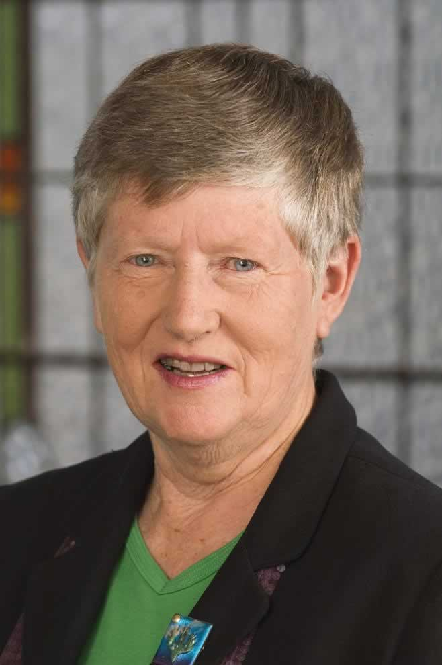
“Jenny has made vast contributions to reducing gender inequality and disadvantage. She has shown incredible passion towards making Australia a fairer place for women.”

Jenny Beacham knows that a determined woman will often ﬁnd a way to ﬁx something that doesn’t seem fair. As a school teacher in the 60s and 70s, Jenny knew how important equal access to quality education played in giving people better social and economic prosperity. The poorer outcomes and gaps however she saw between rural versus city; females versus males; public versus private, and pupils living with racial or other disadvantage strongly motivated Jenny.

It was a culturally significant time for women like Jenny to push back hard on existing power structures. Jenny knew the value of female networks to strengthen that push towards structural and cultural changes. During the 1980s to mid-90s, Jenny fully immersed herself in politics with roles including being: an electoral ofﬁcer for Joan Kirner, (Victoria’s first female Premier); an ALP organiser; a dynamic partner as Lady Mayoress; a senior advisor for then Premier Kirner; a State Secretary of the Victorian ALP; and a political candidate. Jenny sought political office and despite not winning, Jenny continued working behind the scenes, to advance the status of women. Jenny still provides mentorship for female candidates – particularly rural and indigenous ones.

Candy Broad
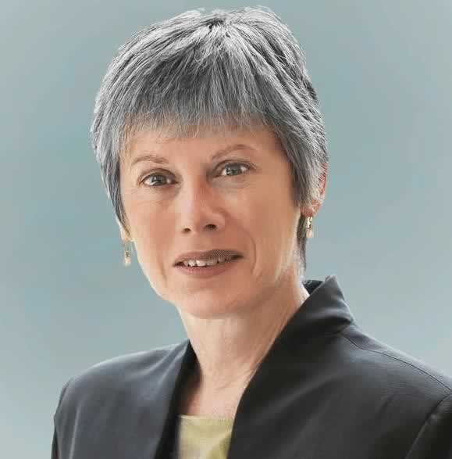
“The loyalty, tenacity and generosity that Jenny shows are qualities that have been admired by many others and have helped her be able to make so many significant changes for women.”

Candy Broad grew up during the feminist social changes of the 1960’s and 70’s which was one of the main influences on her decision to pave her way into a career around improving gender equity and social and environmental justice. Candy has been a long term Hepburn Shire resident but has had a number of significant achievements contributing to public life. From an early age, she understood the need for a long-term network of likeminded females to support and influence each other in effecting change. From 1993 to 1999 Candy campaigned women’s rights within the ALP, working as an assistant of the National Secretary.

She played a significant role in the 1994 introduction of the ALP’s affirmative action scheme, aiming to have women pre-selected in 35 percent of winnable seats. During 1996 she became a founding member of Emily’s List Australia, a campaign designed to increase the number of women MP’s in our state, territory and federal Parliaments. Candy worked with women such as Kay Setches and Joan Kirner, building support for the women in Victoria, gradually spreading the changes nationally. Arguably one of Candy’s biggest achievements to date, is the Abortion Law Reform Bill that she proposed into Parliament in 2008. The bill passed overwhelmingly on a conscience vote by members of all parties. Effectively this led to the decriminalisation of abortion and improvement of women’s health.

Elsie Miller
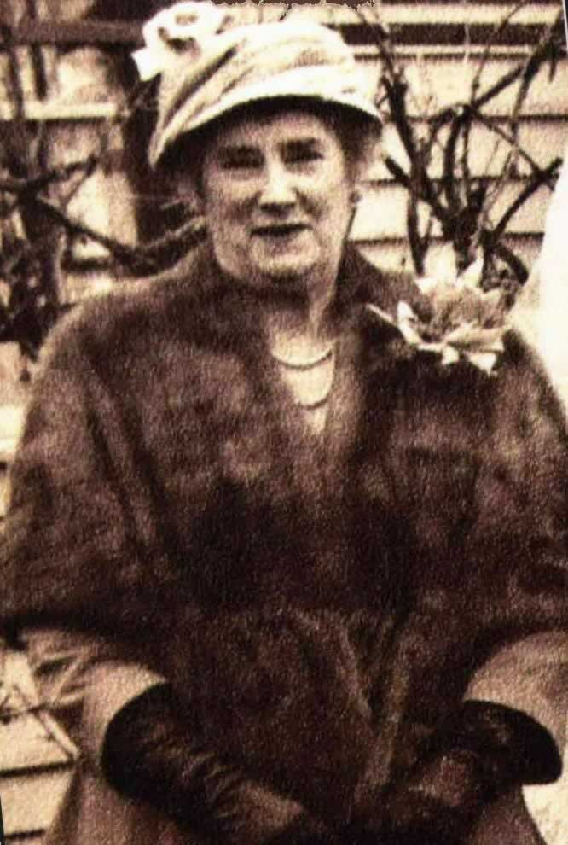
“During the 1960s, Elsie’s work left an indelible mark on the Daylesford community in the form of the West St Centenary Flats.”

Elsie Miller, nee Fleischer, was born in Yandoit on the 21st of September 1894 and grew up at Glenlyon where she later taught at the State School. In 1939 she joined the Daylesford Ladies Benevolent Society of which she was a member for 36 years and served on the committee for most of them. The DLBS was set up in 1863 to relieve the needs of the poor, particularly females in Daylesford and surrounding districts by supplying them with food, clothing and necessities. On August 23rd, 1968, the Daylesford Advocate reported that it was the drive and commitment of Elsie Miller that allowed the Society to further its long term dream of affordable housing in the 1960s, 70 years after the first housing venture, the Jubilee Flats in East St.

To do this she actively sought help from local politicians to retain land in West Street that had been reserved for the Benevolent Asylum. While it had been the desire of all members to provide housing for women in Daylesford, it was Elsie who seized the moment and made that dream a reality. Several accommodation units were built after Elsie used every bit of her time and energy to secure the agreement for them to be built. As Secretary of the Benevolent Society, Elsie managed the change in the constitution of the society to enable it to be registered as a charitable body with the Hospital and Charities Commission, ensuring eligibility for Government funding which provided better resources for women residing in the Daylesford district.

