Women’s Honour Roll 2022

Recipients:
- Joanne Pegg

JOANNE PEGG

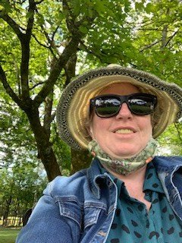
Jo has been a tireless advocate for social inclusion and her passion for inclusive learning has provided support for many students who are on the fringes of mainstream learning.

In 2018 Jo advocated for Bullarto Primary School to be one of ten schools, across the southwestern region of the Education Department, to pilot the Inclusion in Schools Program. The pilot program aided in the review of funding for additional needs students in the Victorian education system. From the success of the program the new inclusion funding model will commence this year.

Jo has been a teacher since 1999, with 6 years as a Principal in small schools. Jo completed her Masters in School Leadership as a single mum, while working full time. Jo’s success in cultivating an inclusive and supportive environment at Bullarto Primary School has led to enrolments increasing from 4 students in 2018 to 22 this year.

Jo holds a Black Belt in Karate and trained for this while pregnant (it was the clubs first Black Belt baby!). As a 15-year-old, Jo was the recipient of the Girl Guides VP (highest recognition in Girl Guides). Jo has also lived and studied abroad in Japan.

Jo’s personal experience has driven her to help educate and support parents of children with additional needs to have a voice, be proud and advocate for their child.

