Women’s Honour Roll 2011

Recipients:
- Julieanne Regan
- Rhonda Smith
- Margaret Giles

Julieanne Regan

Julieanne Regan
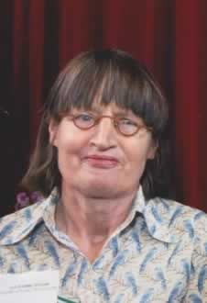
Julieanne Regan was born in Melbourne and later lived in Brunswick and Coburg where she did community work with the homeless and youth unemployed. She came to the Hepburn Shire in 1991 with her son Kit.

Some of her many achievements reflect her interest in the arts and the environment, e.g. the art installation and garden at the Daylesford Library and recycling waste management projects. Others reflect her high ethical values, passion, drive, and commitment to social justice and gender equality. These include her founding at local level humanitarian organisations such as OXFAM and the East Timor ‘Bobonaro Friendship Group.”. It also includes her dogged and unflagging pursuit of ‘good governance’ and accountability by our local government leaders, bureaucrats and other community organisations. Julieanne is most proud of her commitment to attending council meetings at a time when there was apathy after amalgamation. During this time, she would often be the only member of the public in attendance. She challenged and questioned despite lack of support from others at these meetings. In her own words “I was a thorn in their side”. Julieanne hopes she has provided opportunities for women to challenge and question Council. Equally important to Julieanne was her lobbying to raise the awareness in Council of the need for child care to enable women with young children to participate in council activities and decision-making.

All these achievements helped to advance the status of women, enabling them to expand their lives, and demonstrate her leadership qualities.

Rhonda Smith
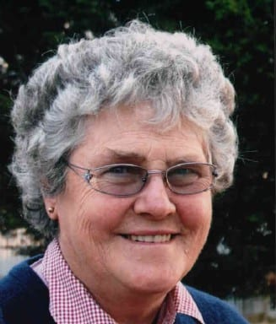
Like all country children even at an early age Rhonda Smith displayed qualities of leadership, responsibility, willingness to give, and an easy get to know you personality, all of which have continued to this day.

Rhonda has involved herself in a great deal. She has been involved in the Dean CFA from 1985-2007 earning a 30 year service badge for contributing both as a Communications Officer and a member. She has also been a member of the Newlyn Community Complex, the Rocky Lead Landcare Group Inc., the Daylesford Highlands Gathering Society and is the founding member of the Daylesford Spa C.W.A.— Night Branch. Rhonda is involved heavily with the secretary of the Australian Ploughing Competitions and Australian Representative on the World Committee, where she has done herself great pride as one of only three women on the World Board together with 27 males. She is very proud to hold this position for 13 years in a male dominated sport.

As partner to David Smith during his 14 years of Local Government service, three of which were as Mayor of the Shire, she has always been willing to be available to her community. Rhonda hopes that she has helped to give women confidence that they can achieve any public position should they put their name forward or hand up.

Margaret Giles
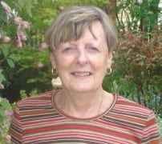
Mrs Margaret Giles, daughter, wife, mother, friend, community member, committee member and board member. A woman who is caring, compassionate, strong, professional, passionate and a leader. The countless hours of support and dedication she has given to her family, business and community over the years show the strength of this remarkable woman.

Margaret is now retired and operates Rossmore Cottage, a B&B; which she tends to with pride and ensures that all her guests receive the highest of care and are introduced to the wonderful history and future of the town she loves so dearly. Margaret, an energetic mother to three and proud grandmother to four, was primary carer for her husband Neville until he died recently after a battle with cancer. Margaret’s experience includes a varied career in nursing, a long term small business owner, eight years as a career’s advisor/employment officer in Daylesford, the only female Commissioner for the Amalgamated Shires of Creswick, Clunes, Talbot, Daylesford, Glenlyon and numerous committee and board positions Margaret possesses such a wealth of experience and knowledge, which she eagerly shares with women to encourage their involvement in their communities.

One of Margaret’s many achievements is the inception of a Magic Pudding Playground Working Group; a group of young mothers engaged and passionate about building a unique playground in Creswick. The Playground is to be a site of the Creswick of the Lindsay Arts Trail project which aims to promote Creswick as a tourism destination. Margaret is an honest, hardworking, passionate woman who deserves to be recognised for her tireless work within the Creswick community and Hepburn Shire.

