Women’s Honour Roll 2015

Recipients:
- Carole White
- Tina Banitska
- Michelle Leishman
- Alla Wolf-Tasker
- Catherine (Kit) Trewhella (Posthumous)

Carol White

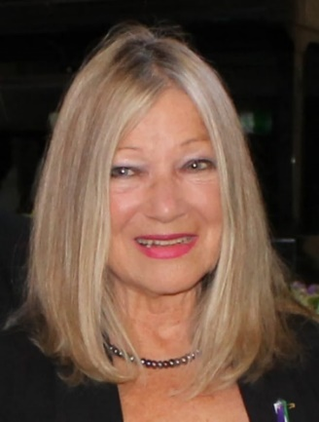
In more than two decades restoring and operating one of the region’s most spectacular tourist attractions, Lavandula, Carol White has quietly and determinedly shown how to build a thriving enterprise and has inspired a community. She inspires as an example to women by her successful business.

Tina Banitska
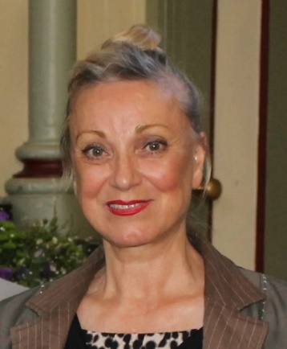
Converting a dream into reality, persistence and determination paid off for Tina.

Tina is also committed to young and emerging artists and supports various schools and community groups conducting workshops and fundraising projects. She has been an inspiration and mentor for young women.

Michelle Leishman
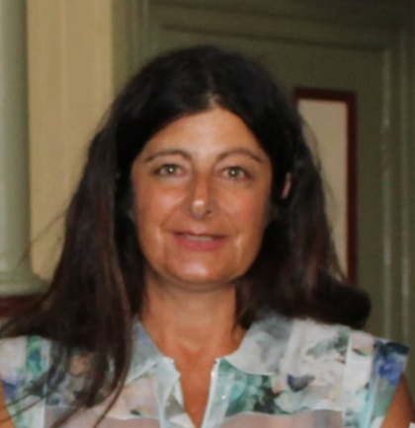
Michelle’s contribution to the advancement of women is an inclusive and empowering role, through the founding and funding of the Sidinda Health Clinic in rural Zimbabwe.

Through the clinic Michelle has centred initiatives for women’s health, social advancement and employment. Additionally, Michelle’s leadership has been able to create relationships between the Zimbabwean women and local Clunes residents.

Alla Wolf-Tasker
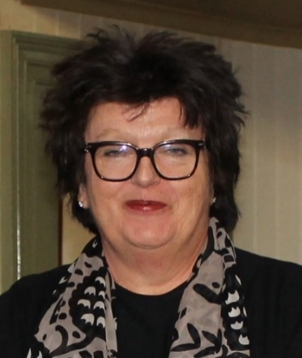
Alla’s unswerving vision created an Australian food and getaway attraction that has clearly played a ground breaking role in Hepburn Shire history.

Celebrated internationally as the single most influential individual in the region’s reputation as a fine food destination, few have achieved more to shape the face of Australian regional dining. Alla remains pivotal to creating a demand for local produce in this region. Her leadership as a woman in a highly competitive industry is legendary.

Catherine (Kit) Trewhella (Posthumous)
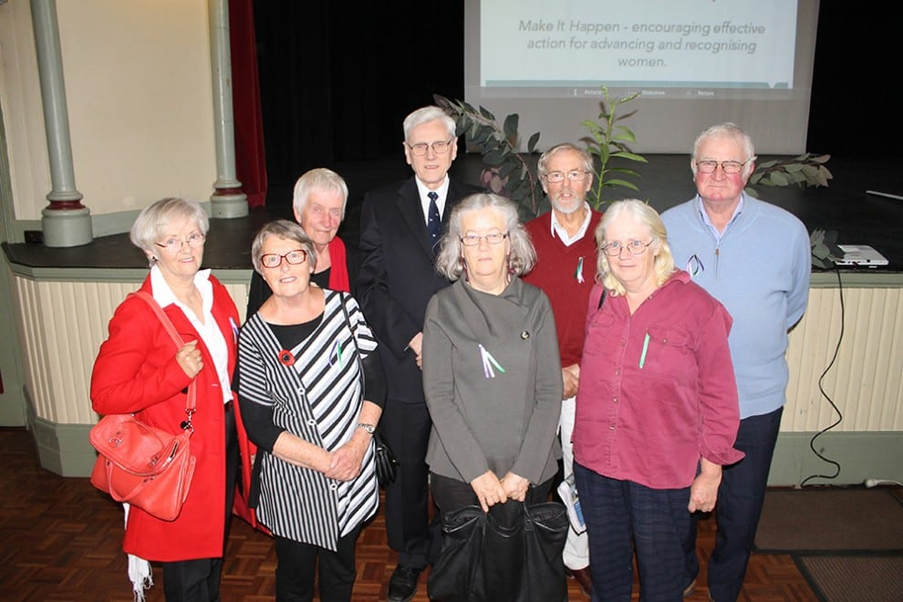
Kit was born in 1896, one of 6 children growing up in a shepherd’s hut in Blue Mount, just out of Trentham. She lived her adult life in the Trentham area apart from a few years in Melbourne working for Johns and Waygood and learning drafting.

Her father William was an engineer, responsible for inventing what is known as “Trewhella Jacks”, an implement initially used in the tree milling industry to remove tree stumps. He and his brother set up the Trewhella foundry in Trentham to manufacture these jacks and Kit worked most of her adult life here. Both Kit’s father and Grandfather Benjamin, a farmer, Justice of the Peace, Councillor, Trentham Masonic Lodge founder and educator, were role models for her. Her mother died when she was young.

