Women’s Honour Roll 2016

Recipients:
- Gale Orford
- Julie Ingleby

Gale Orford
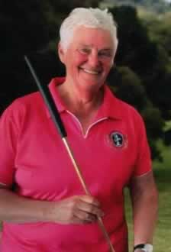
Gale was a second mother to a generation of children. They’ll boast about her stellar hugs, her guiding voice and bottomless love.
Educating and empowering children was Gale’s greatest strength. The result is a generation of children passing on her wisdom, work ethic and love. That is what makes our community strong.

Daylesford was lucky to be gifted with Gale Orford…a woman who gave everything she had for her community and its children.

Julie Ingleby
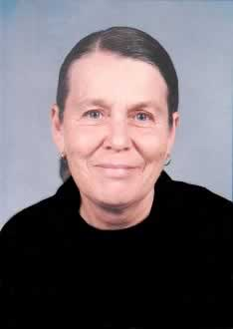
Julie Elizabeth lngleby was born in 1944 and her first home was a Nissan Hut in Camp Pell, a disused army camp in Parkville, Victoria which housed around 3000 people who a had been displaced by inner city slum reclamation.
She studied Fine Art at the Royal Melbourne Institute of Technology on a teaching bursary and supported herself as a cleaner, a photographic colourist and a detailer of trucks- any work that suited her studying. After graduation she paid back her bursary as she didn’t want to be forced into teaching before she was ready.

She married at 18 and had two children and as a family they travelled extensively in Europe over a number of years where she enjoyed seeing the works she had studied, exploring galleries and museums and immersing herself and her family in different cultures noticing in particular how women were treated in different cultures.

She became and organiser in the teachers ‘union but resigned to return to the classroom as her major love was teaching, particularly those who didn’t fit into traditional schools. She strongly supported the educational innovation of specially written comic books and strips in schools to encourage non-readers to read. She wrote and published extensively in the genre.

Her Master’s thesis in 1985 “Action Research and the Politics of Change in Working Class Schools” emphasised the novel notion of individual student needs and was to become a blueprint for many Departmental schools. Her PHD thesis “Advanced Educational Theory and Community Development” satisfied two faculties and earned her two PHDs. Again, this was a practical working document that was made available to schools.

In death she was still innovating as the first person to be buried in a shroud in our local cemetery. Her reason? It was more environmentally acceptable.
Her rough-hewn headstone reads: Julie Elizabeth lngleby ‘Woman Mother Comrade’ Abstract – Citation written by Marjorie Atkinson.

