Women’s Honour Roll 2020

Recipients:
- Arlene Geoffrey
- Dallas Kinnear
- Loretta Little
- Sarah Glenny (posthumous)

ARLENE GEOFFREY - “Mrs G”

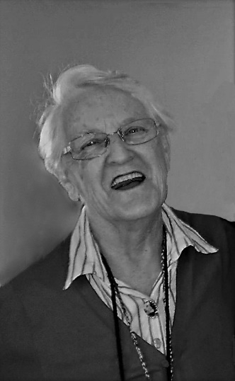
“Mrs G would encourage us all to push ourselves and always do our absolute best with constant positive affirmation”

Arlene moved to Creswick when she was 11 and after 2 years at the local primary school left to go into dressmaking with her mother. Her limited education and her shyness and introversion led her to feel inferior and that she was unintelligent.

When she was three her mother started taking her to pantomimes and she was captivated by everything to do with the theatre. She learned piano and tap and in her 30’s she completed Diploma of Dress Design obtaining a Distinction. This formal education gave her greater confidence and developed her love of musical theatre and shortly after she became wardrobe mistress at Ballarat Lyric Theatre, a role she held for the next 20 years. ‘Mrs G’ as she became known established Vertex Theatre in 1979 and ran this for over 23 years with the help of her husband and daughter. She adapted or wrote the scripts and for many years her husband wrote the piano accompaniment.

She undertook all her work as a volunteer, donating the profits to many charitable organisations and agencies. 560 children participated in various shows over 23 years and the theatre grew to be an outstanding vehicle for young people to develop confidence and identity. Students were encouraged to be involved in everything from set design to script writing and direction of performance, all in a supportive and collective environment. Mrs G’s legacy after Vertex closed was the establishment of Jape and then Jelly Japes which continues today – run largely by young women who have been through Vertex and many of whom have become her lifelong friends.

In addition, she initiated a tapestry acknowledging the history of Creswick, she established Old Crocks Choir at the Senior Citizens which performed for 14 years, and she still plays the piano at John Curtin Aged Care. She also writes and illustrates children’s books which she donates to Creswick Library. ‘Mrs G’ has been a role model for many young people, showing that women can achieve anything.

DALLAS KINNEAR

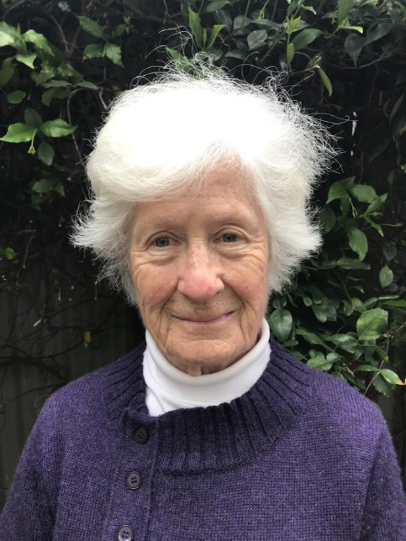
“She is one woman who fearlessly continues to exercise her power and passion”

Dallas was born into an affluent business family and along with her twin brother was sent to boarding school at age 7. She remembers feeling frightened, that she was a nuisance and not good enough, which is why her parents didn’t want her at home. To cope she sought to please all in authority.

Following the breakup of her marriage, Dallas felt brave enough to live a less affluent lifestyle and felt called to be in the service of those less fortunate than herself.

During a six-month camping trip around Australia with her four children she learned how little one really needs to live a rich life. Her strong feminist ethics and environmental activism were galvanised, and in 1984 she committed herself to be a full-time environmental activist, determined to make a difference.

Dallas worked for the Australian Conservation Foundation for many years both as an employee and volunteer, where amongst many other achievements she co-ordinated the ACF Ozone Project.

In 1989 Dallas raised funds and made a 30-minute video for SBS Schools Program on recycling entitled “It’s Not All Rubbish”. She was 30 years ahead of the ABC’s ‘War on Waste.’

One of Dallas’ ‘careers’ was to stop illegal developments in Daylesford, and the encroachment of private interests onto public land. She was involved in a campaign to declare Hepburn Shire Genetic Engineering free. She was instrumental in setting up CRAG - Carbon Rationing Action Group in Hepburn which educated residents on ways to make their homes more energy efficient.

Dallas has been a resident of Hepburn Shire for 25 years. At 84 years she is still involved in climate action and for the last 12 months has been one of the organisers of the successful Daylesford Repair Café. Her friends say Dallas is a natural and gifted leader. She has an exemplary record of campaigning in ways which both educate and inform. She willingly shares knowledge and contributes constructive ideas and strategies. She is a remarkable role model for women and is respected, trusted and the friend of many.

LORETTA LITTLE

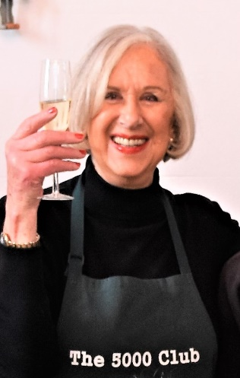
“When Loretta puts her mind to something, she is a force of nature”

Loretta was born in Swan Hill and grew up in a small farming community near Goodnight, NSW. After attending tiny Tooleybuc School, she moved to MLC in Melbourne and went on to obtain honours and a teaching scholarship.

After teaching in West Preston and lecturing at Toorak Teachers College Loretta married and moved to Bass, South Gippsland. There she developed and managed a successful Simmental cattle stud. This farming enterprise encompassed bovine genetics and she was innovative and successful.

Following divorce, in 2000 Loretta became involved with Afghan boat people and along with Dr Nouria Saleh set up “Welcome”. This organisation focused on helping Afghan women and children and amongst other activities trained and retrained women who came from a culture that limited women’s roles.

In the early 2000s Loretta moved to Daylesford and decided the town needed a cinema. She recruited a group of likeminded people to raise funds and the cinema started in 2012. She has more recently led the effort to establish a cinema in The Rex Arcade, and the cinema will be re-established with the completion of the Hepburn Hub.

In 2011 Loretta started the Daylesford 5000 Club which provides a free weekly 3 course meal. This also provides all who attend social interaction in a welcoming and accepting environment. Her capacity to enhance confidence, participation, engagement and self-esteem is quite remarkable. The 5000 Club has now been running for more than 8 years and recently moved to Victoria Park Pavilion where it goes from strength to strength and is now led by long term volunteers who continue to ensure it runs successfully.

Loretta has a long list of other community achievements. She is much loved by those she works with, and highly regarded as a determined leader and a principled community activist. She has a particular skill in engaging volunteers, as demonstrated across her major community activities. And she is seen by many women as a ‘unique‘ woman who can do anything.

SARAH GLENNY (Posthumous)

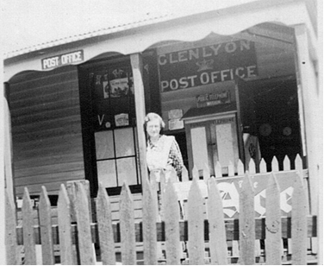
“Miss Glenny led by example and was a role-model in community service and diligence in her responsibilities”

Sarah was born in 1884 in Glenlyon. She attended Primary School in Glenlyon and Grammar School in Castlemaine for four years, excelling academically. She was unusual for her era, being better educated than her peers including the bulk of the male population.

Sarah’s parents owned and ran Glenny’s Hotel, Store and Post Office. Her father died in 1909 and Sarah took over his role as Postmistress at the age of 33. She also operated the Telephone Exchange when George, her brother, joined up in 1915. He returned from and war an invalid however was able to help in the post office. With short breaks Sarah ran the post office from 1909 to 1950. She was diligent and could always be relied upon, especially to connect calls at any time. She corresponded with many young men in WW1, and supported families in grief.

Miss Glenny as she was known also had a high profile in public life and community service.
She was the founding member of the Red Cross at Glenlyon in 1914, was its treasurer for many years and led a group of women who worked tirelessly to raise funds to benefit Australian Soldiers overseas and other deserving charities. She received the Red Cross Long Service Medal in 1953.

She served as secretary of the Church of England Ladies Guild for many years, working for the benefit of church and community.

Miss Glenny was legendary for her heroism in 1944, when at the age of 70 she stayed at the Glenlyon post Office to ensure communications continued as two bushfires burned towards Glenlyon.

Sarah’s education gave her the confidence and skills to participate in public and professional roles and hold a number of leadership positions throughout her long life. From 1896 when she left school until well into her eighties, she devoted herself to the community providing a role model for other women, comforting them in sad times and leading and encouraging them to participate on the broader community.

