Indigenous plants for landscaping - Hepburn Shire

What is an ‘indigenous plant’?

Indigenous plants are not only native to Australia, but they are plants that occur naturally in your local area. A list of species suitable for gardens follows.

Why plant indigenous plants?

Indigenous plants are an important source of food and shelter for our local fauna. They have co-evolved with the local environment so they can survive local rainfall patterns and soils.

Using indigenous plants also:
- Helps preserve the local plant populations
- Can save water and money
- Enhance wildlife corridors and provide links between fragmented bushland areas
- Contribute to the distinctive local character of the Hepburn Shire
And they look great too!

Bioregions

‘Bioregions’ group broad areas of similar climate, terrain, geology, and vegetation. There are 28 bioregions identified within Victoria and three of these span the Hepburn Shire.
Knowing your bioregion can help you select appropriate plants that will thrive in your local conditions. The species list below indicate appropriate bioregions.
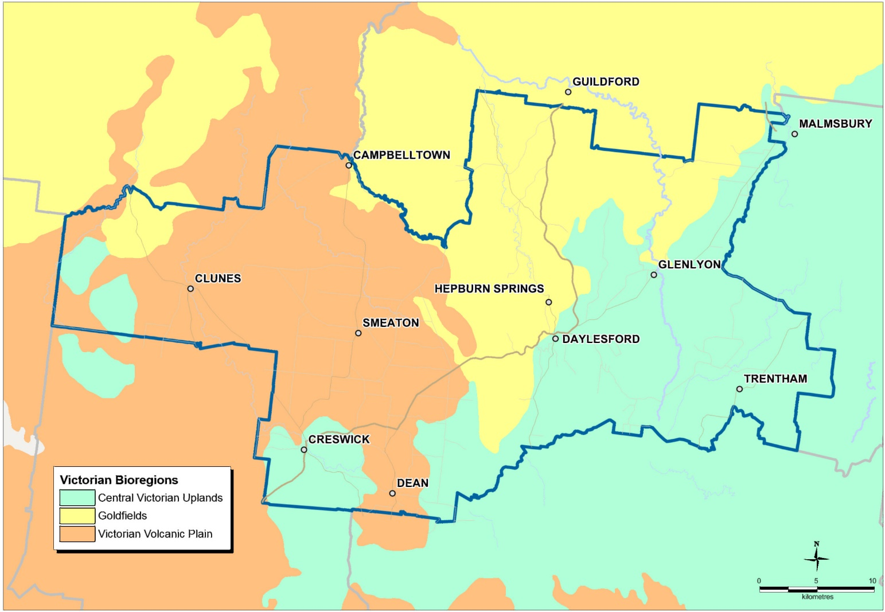
Where can I learn more about growing indigenous plants?
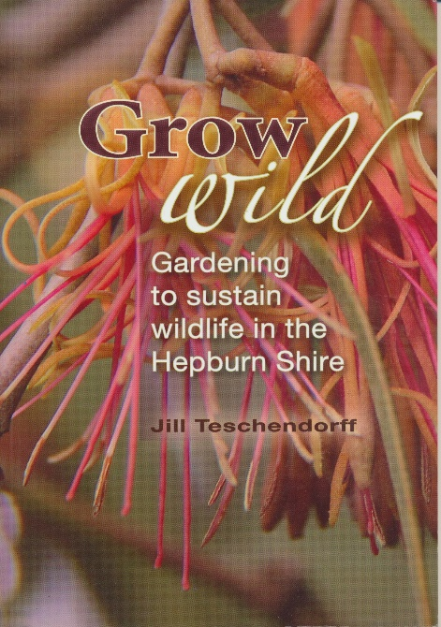
Hepburn Shire has helped fund the book ‘Grow Wild’ by Jill Teschendorff, produced by Wombat Forestcare. This book is all about gardening to sustain wildlife in the Hepburn Shire and is the source of most of the information on these pages. This book is available at libraries, local bookstores and newsagents or can be ordered through Wombat Forestcare.

Where can I buy indigenous plants?
Several nurseries specialise in growing indigenous plants and are a great source of information.
Note that most of these nurseries are by appointment only.

Ballarat Wild Plants
435 Joseph Street, Canadian 3350
0409 388 014

Goldfields Revegetation
230 Tannery Lane, Mandurang 3551
03 5439 5384
www.goldfieldsrevegetation.com.au

Grow Locals
42B Anslow Street, Woodend Victoria 3442
Tully Sumner - info@growlocals.com.au
0412 806 597
growlocals.com.au

Habitat Native Plant Co.
86 Maiden Gully Road, Maiden Gully 3551
0417 544 159

Neangar Nursery
8 McClelland Drive, Eaglehawk 3556
03 5446 9260

Newstead Natives
Frances Cincotta- By appointment
4 Palmerston Street, Newstead 3462
03 5476 2691

Wombat Native Plants
Jeremy Neale- By appointment
South Bullarto Road, Bullarto 3461
landmanagement@me.com
www.wombatnativeplants.com

SPECIES | COMMON NAME | BIOREGIONS
 |  | Goldfields | Central Victorian Uplands | Victorian Volcanic Plain
Climbers
Billardiera scandens | Common apple-berry |  | x
Clematis aristata | Mountain clematis |  | x
Hardenbergia violacea | Purple coral pea | x | x
Groundcovers and small plants
Ajuga australis | Austral bugle | x | x
Arthropodium strictum | Chocolate lily | x | x | x
Brachyscome multifida | Cut-leaf daisy | x | x
Bulbine bulbosa | Yellow bulbine lily | x | x | x
Burchardia umbellata | Milkmaids | x |  | x
Chrysocephalum apiculatum | Common everlasting | x | x | x
Chrysocephalum semipapposum | Clustered everlasting | x | x | x
Coronidium scorpioides | Button everlasting | x | x
Dichondra repens | Kidney-weed | x | x | x
Epacris impressa | Common heath |  | x
Kennedia prostrata | Running postman | x | x | x
Pelargonium australe | Austral stork’s-bill | x | x | x
Pelargonium rodneyanum | Magenta stork’s-bill | x | x
Pultenaea pedunculata | Matted bush-pea | x | x | x
Tetratheca ciliata | Black-eyed Susan; Pink bells | x | x
Viola hederacea | Native violet | x | x
Wahlenbergia communis | Tufted bluebell | x | x | x
Xerochrysum viscosum | Sticky everlasting
Grasses
Austrostipa mollis | Spear grass | x | x | x
Dichelachne crinita | Plume grass | x |  | x
Microlaena stipoides | Weeping grass | x | x | x
Poa labillardierei | Common tussock grass | x | x | x
Poa morrisii | Velvet tussock grass | x | x | x
Poa sieberiana | Fine-leaf tussock grass | x | x | x
Rytidosperma spp. | Wallaby grass | x | x | x
Rytidosperma pallidum | Silvertop wallaby grass | x | x
Themeda triandra | Kangaroo grass | x | x | x
Rushes, sedges and wetland plants
Carex appressa | Tall sedge | x | x | x
Cycnogeton procerum | Water ribbons | x | x | x
Dianella revoluta | Black anther flax lily | x | x | x
Dianella tasmanica | Tasman flax lily |  | x
Gahnia sieberiana | Red-fruited saw-sedge |  | x
Isotoma fluviatilis | Swamp isotome | x | x | x
Lomandra longifolia | Spiny-headed mat rush | x | x | x
Lythrum salicaria | Purple loosestrife | x | x | x
SPECIES | COMMON NAME | BIOREGIONS
 |  | Goldfields | Central Victorian Uplands | Victorian Volcanic Plain
Small to medium shrubs
Acacia acinacea | Gold dust wattle | x |  | x
Acacia mitchellii | Mitchell’s wattle | x | x
Acacia paradoxa | Paradoxa wattle; Hedge wattle | x | x | x
Cassinia aculeata | Common cassinia | x | x | x
Correa glabra | Rock correa |  |  | x
Correa reflexa | Common correa | x | x
Daviesia latifolia | Hop bitter-pea | x
Dodonaea viscosa | Sticky hop bush | x |  | x
Grevillea alpina | Cat’s claw grevillea; Downy grevillea | x | x
Indigofera australis | Austral indigo | x | x | x
Leptospermum continentale | Prickly tea-tree | x | x
Leptospermum obovatum | River tea-tree |  | x
Olearia myrsinoides | Silky daisy-bush |  | x
Prostanthera denticulata | Rough mint bush | x
Prostanthera lasianthos | Christmas bush |  | x
Solanum laciniatum | Kangaroo apple | x | x | x
Medium to large shrubs
Acacia verticillata | Prickly Moses |  | x
Bursaria spinosa | Sweet bursaria | x | x | x
Callistemon sieberi | River bottlebrush | x | x | x
Hakea decurrens | Bushy needlewood | x
Melicytus dentatus | Tree violet | x | x | x
Small to medium trees
Acacia mearnsii | Late black wattle | x |  | x
Acacia nanodealbata | Dwarf silver wattle |  | x
Allocasuarina littoralis | Black sheoak |  | x
Allocasuarina verticillata | Drooping sheoak | x |  | x
Banksia marginata | Silver banksia | x | x | x
Large trees
Acacia dealbata | Silver wattle | x | x | x
Acacia melanoxylon | Blackwood wattle | x | x | x
Eucalyptus dives | Broad-leafed peppermint | x | x
Eucalyptus leucoxylon | Yellow gum | x
Eucalyptus melliodora | Yellow box | x | x | x
Eucalyptus obliqua | Messmate |  | x
Eucalyptus ovata | Swamp gum | x | x | x
Eucalyptus radiata | Narrow-leafed peppermint |  | x
Eucalyptus rubida | Candlebark | x | x | x
Eucalyptus viminalis | Manna gum | x | x | x

