Women’s Honour Roll 2023

Recipients:
- Anneke Deutsch
- Joyce Orr
- Mariwyn (Tess) Brady
- Joee Aganetti-Fraser
- Marie Magdalen Lewis (posthumous)

ANNEKE DEUTSCH
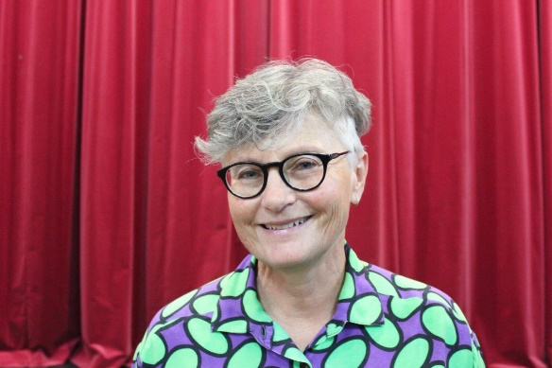
Anneke was one of the first women to work in her chosen profession, Prosthetics and Orthotics. In the 1980’s it was a profession traditionally staffed by men.

Anneke was highly valued by her health team colleagues for her integrity and expertise in her clinical and technical work. Additionally, women who joined her in the Prosthetics and Orthotics world found strength in supporting them to make their way in a male dominated industry.

She gave wise counsel in dealing with gender politics and power imbalances, helped women analyse approaches to change attitudes around equality and helped normalise women as effective, valued participants in the workforce. She was an inspiration to women entering the field and to enlightened men also.

In parallel to this professional role, Anneke has worked for many years to advance the lives of lesbian women at a local level and more broadly in society.

For 10 years, Anneke volunteered her time to the Matrix Guild of Victoria, which exists to raise awareness of the health, housing and care needs of older lesbians.

Locally, Anneke is President of the Older Women in Cohousing Inc, a group aiming to build housing for women based on collaboration, sustainability, accessibility, and a blend of opportunities for privacy and for social interaction.

Through all these roles Anneke continues to improve the lives of women. She is amazing.
JOYCE ORR

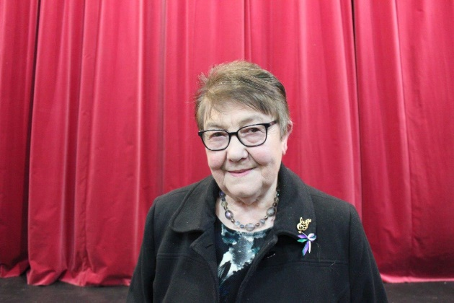
Joyce is an unassuming trailblazer who has led by example and demonstrated through decades of volunteering the many opportunities for women to excel within their community, all whilst raising five children.

Since the 1960’s Joyce has encouraged, driven and supported her own children through her passion for music and involvement in the Daylesford Brass Band. She has been an active member of the band for over 40 years.

She quietly challenged gender norms early on by being the first female Treasurer for the Daylesford Historical Society and was an active member for 40 years.

Joyce helped make the lives of those living with a disability better through her fundraising work and craft events at Windarring Centre.

What makes Joyce special is that she acts and advocates for everyone, there is no single issue or cause. She is a humanist with great capacity to care for those she sees in need of support.

The most impactful role models are those who demonstrate that everyone can contribute and make a difference within their community, there are very few volunteer activities or committees that Joyce has not been involved in!

MARIWYN (TESS) BRADY
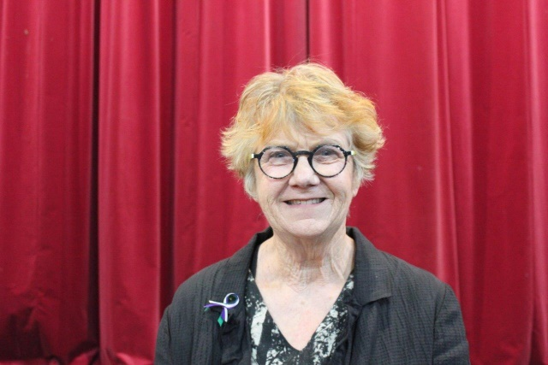
Tess Brady has worked for two decades as a powerful agent for change in her community of Clunes, advancing the status of women by empowering them to take on change and showing that if you have a vision and determination, anything is possible.

A lifetime learner, Tess has an honours degree in Philosophy, a Masters in Educational Linguistics and a Doctorate in Writing. She applies creativity in thinking to reshape boundaries and redraw landscapes, particularly when it comes to women taking on leadership roles.
With women still unrepresented in formal leadership structures, Tess actively mentors and encourages other women to back their own visions and dreams.

Tess emerged as an active community leader very soon after her arrival in Clunes in 2003. Her intellect, energy and drive helped turn opportunities into real outcomes, and she has always been happy to share her knowledge and networks to help others develop projects across the community.

Tess’s community leadership experience, often served concurrently, includes:
- Establishing Clunes as an active participant in the Shire-wide Words in Winter event
- founding member of Creative Clunes Inc (including Chair from 2012-14 and terms as Artistic Director of Clunes Booktown Festival)
- community representative on the Advancing Country Towns Management Committee (funded through Department of Planning and Community Development)
- active member of the Clunes Artists Group
- major involvement in starting the Clunes Ceramic Award
- regular host/presenter and programmer of Clune’s monthly Sunday writers talks
- ongoing liaison with Writers Victoria to arrange workshops
- assisting Clunes community groups in writing grant applications
- founding member of Clune’s Attitude - Ageing Well in Clunes program

Thank-you Tess for your dedication to Clunes.

JOEE AGANETTI-FRASER

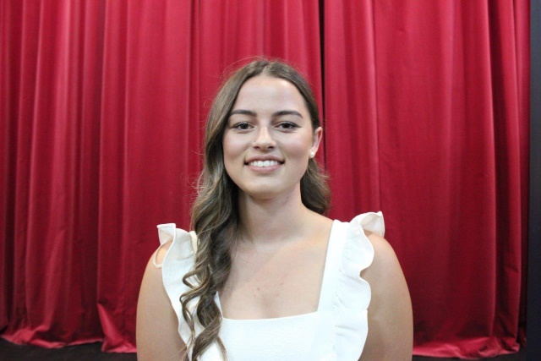
Joee, a fifth-generation young farmer from the Hepburn Shire took a stand by ploughing her opposition to AUSNET installation into the family farm hill at Mount Prospect.

Joee works full-time on the farm, studies agriculture, works casually at the Swiss Mountain Pub and for a shearer as a roustabout, whilst still finding the time to advocate on the community’s behalf.

Joee is the instigator of the community group and Facebook page opposing the AUSNET installation and has shown that she is a strong leader, inspiring a wide group to follow and fight for the campaign. This includes the organisation of many meetings with politicians, media, and engaging with her local and wider community.

ABC Education approached Joee to be part of an education series given her knowledge of not only potatoes but also the mixed farming of sheep and crops. The series is based on young people in agriculture/farming and how farming is a great career choice. This program will be shown in both primary and secondary education schools.

Being a young female farmer, Joee has challenged what is usually seen as a male dominated industry. It takes courage, drive and enthusiasm as a young female to confront what is often out of your comfort zone and we applaud Joee’s passion to build a profile around these challenges.

This attention has, at times, challenged Joee as she is very humble and often says “I’m just fighting for what I believe in, for everyone’s future and mine.”

It’s great to see such a young role model advocating on behalf of the community, well done Joee.

MARIE MAGDALEN LEWIS (POSTHUMOUS)

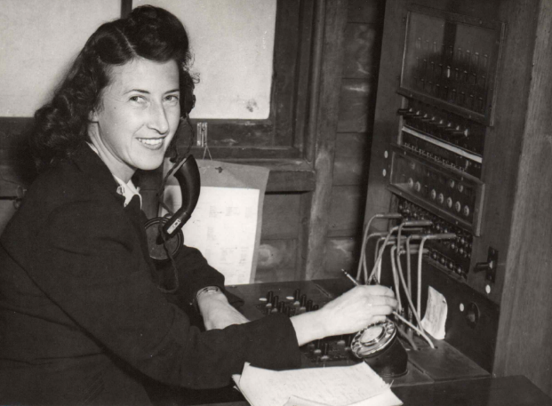
During her life, Marie's career choices challenged traditional stereotypes for the time. Her role working as a Post Mistress and telephone operator at Blampied Post Office, and later by enlisting in the Women's Auxiliary Australian Air Force (WAAAF) showed that she was willing to take on positions that had previously been dominated by men. These roles involved accepting and embracing new technologies.
Marie was one of only approximately 20 women in the Creswick Shire that enlisted in the second world war. She did not hesitate to answer the call and play her part. She is quoted as saying, "If there was something I could do to help, then I was going to do it".
Marie enlisted with the Women's Auxiliary Australian Air Force in 1942. After being posted to various air force bases from Nhill to Melbourne, she was posted to Dubbo as a telephone operator. Marie worked in signals for 5 years, moving up the ranks to become a sergeant. She was given a supervisory role, sharing her skills and expertise in the field with other women in the Women's Auxiliary Australian Air Force.
After the War, Marie returned to Blampied with her husband Harold to raise their 2 young sons, and she operated the Blampied Post Office and Telephone Exchange for over 20 years.
Marie always had a very strong connection with Blampied, and this is evident in her role as the sacristan at St Joseph's Catholic Church which she held for over 40 years - an extraordinary commitment and contribution to the community.
She was also an active and long-time member of the Creswick Golf Club and the Mt Prospect Tennis Association.
Marie was a proud member of the Creswick Smeaton RSL sub-branch, and Anzac Day was always a special day. She attended Anzac Day ceremonies in Creswick right up until the age of 104.
Marie always had a positive outlook on life, and her "can-do" attitude was evident even in her later years. Due to her remarkable age, combined with her intellect and excellent memory, Marie was often approached to share her life story. She was always happy to talk to children from the local schools about her life or share her history with visitors to the John Curtin Hostel.
Marie had an exceptional connection to the Hepburn Shire and was an inspiring and proud member of the community for all of her 106 years.

