BUSHFIRE ATTACK LEVEL ASSESSMENT REPORT

OWNERS DETAILS
Name:
Postal Address:
Contact Number: Email:

PROPERTY DETAILS
Number: Street/Road:
Suburb/Town: Postcode:

PROPOSED BUILDING WORK
Proposed Work:
(i.e. construction of dwelling, extension to dwelling, construction of garage)

BUSH FIRE ATTACK LEVEL (BAL)

Step 1: Relevant fire danger index: (see Clause 2.2.2)

FDI 50  (Alpine Areas) FDI 100  (Victoria General – excluding Alpine areas)

Step 2: Assess the vegetation within 100m in all directions (tick relevant group)
Note 1: Refer to Table 2.3 and Figures 2.3 & 2.4 for description and classification of vegetation.
Note 2: If there is no classified vegetation within 100 m of the site then the BAL is LOW for that part of the site.

VEGETATION CLASS  (see Table 2.3) | - North  - North-East | - South  - South-West | - East  - South-East | - West  - North-West
Group A  Forest and type | - Tall open forest  - Tall woodland  - Open forest  - Low open forest  - Pine plantation | - Tall open forest  - Tall woodland  - Open forest  - Low open forest  - Pine plantation | - Tall open forest  - Tall woodland  - Open forest  - Low open forest  - Pine plantation | - Tall open forest  - Tall woodland  - Open forest  - Low open forest  - Pine plantation
Group B  Woodland and type | - Woodland  - Open woodland  - Low woodland  - Low open woodland  - Open shrubland | - Woodland  - Open woodland  - Low woodland  - Low open woodland  - Open shrubland | - Woodland  - Open woodland  - Low woodland  - Low open woodland  - Open shrubland | - Woodland  - Open woodland  - Low woodland  - Low open woodland  - Open shrubland
Group C  Shrubland and type | - Closed heath  - Open heath  - Low shrubland | - Closed heath  - Open heath  - Low shrubland | - Closed heath  - Open heath  - Low shrubland | - Closed heath  - Open heath  - Low shrubland
Group D  Scrub and type | - Closed scrub  - Open scrub | - Closed scrub  - Open scrub | - Closed scrub  - Open scrub | - Closed scrub  - Open scrub
Group E  Mallee/Mulga | - Tall shrubland | - Tall shrubland | - Tall shrubland | - Tall shrubland
Group F  Rainforest and type | - Tall closed forest  - Closed forest  - Low closed forest | - Tall closed forest  - Closed forest  - Low closed forest | - Tall closed forest  - Closed forest  - Low closed forest | - Tall closed forest  - Closed forest  - Low closed forest
Group G  Grassland | - Low open shrubland  - Hummock grassland  - Closed tussock grassland  - Tussock grassland  - Open tussock  - Sparse open tussock  - Dense sown pasture  - Sown pasture  - Open herbfield  - Sparse open herbfield  - Tussock moorland | - Low open shrubland  - Hummock grassland  - Closed tussock grassland  - Tussock grassland  - Open tussock  - Sparse open tussock  - Dense sown pasture  - Sown pasture  - Open herbfield  - Sparse open herbfield  - Tussock moorland | - Low open shrubland  - Hummock grassland  - Closed tussock grassland  - Tussock grassland  - Open tussock  - Sparse open tussock  - Dense sown pasture  - Sown pasture  - Open herbfield  - Sparse open herbfield  - Tussock moorland | - Low open shrubland  - Hummock grassland  - Closed tussock grassland  - Tussock grassland  - Open tussock  - Sparse open tussock  - Dense sown pasture  - Sown pasture  - Open herbfield  - Sparse open herbfield  - Tussock moorland
EXCLUSIONS  (where applicable) | Circle relevant paragraph descriptor from clause 2.2.3.2.
EXCLUSIONS  (where applicable) | b c d e f | b c d e f | b c d e f | b c d e f

Step 3: Distance of the site from classified vegetation (see clause 2.2.4)

DISTANCE TO VEGETATION | Show distances in metres
DISTANCE TO VEGETATION | North | South | East | West

Step 4: Determine the effective slope of land under the classified vegetation

EFFECTIVE SLOPE | North | South | East | West
 | Upslope
Slope under the classified vegetation  (taken from the building) | Upslope/0º  | Upslope/0º  | Upslope/0º  | Upslope/0º 
 | Downslope
 | >0 to 5  | >0 to 5  | >0 to 5  | >0 to 5 
 | >5 to 10  | >5 to 10  | >5 to 10  | >5 to 10 
 | >10 to 15  | >10 to 15  | >10 to 15  | >10 to 15 
 | >15 to 20  | >15 to 20  | >15 to 20  | >15 to 20 

Step 5: Determination of Bushfire Attack Level (BAL)
Refer to Table 2.4.2 for FDI 100 (Victoria General) or Table 2.4.4 for FDI 50 (Alpine areas)

Using the relevant table, determine the Bushfire Attack Level (BAL) for each of the vegetation classifications determined at Step 2, the distance from the site determined at Step 3 and the effective slope determined at Step 4.

Select the highest Bushfire Attack Level (BAL) obtained above.

The BAL for this site is: | ❑ Low | ❑ 12.5 | ❑ 19 | ❑ 29 | ❑ 40 | ❑ FZ

Date of assessment:

ASSESSORS DETAILS
Name:
Postal Address:
Contact Number: Email:

STATEMENT: I have taken all reasonable steps to ensure that the information provided in this assessment is accurate and reflects the conditions on and around the site and allotment on the date of this assessment.

Signed:

Date:

ATTACHMENTS:
- Site plan: (attachment 1)
- Photographs:
North and East aspect vegetation (attachment 2)
South and West aspect vegetation (attachment 3)

Notes

NOTES Extract from AS3959-2009 - Section 2 Determining the Bushfire Attack Level (BAL)

CLAUSE 2.2.2 Step 1 – Relevant Fire Danger Index (FDI)
The relevant FDI shall be determined in accordance with Table 2.1 for the identified jurisdiction or region within a jurisdiction.
TABLE 2.1 – Jurisdictional and Regional Values for FDI
State/Region |  | FDI
Australian Capital Territory |  | 100
New South Wales | - Greater Hunter, Greater Sydney, Illawarra/Shoalhaven, Far South Coast and Southern Ranges fire weather districts | 100
New South Wales | - NSW Alpine Areas | 50
New South Wales | - NSW general (excluding alpine areas, Greater Hunter, Greater Sydney, Illawarra/Shoalhaven Far South Coast and Southern Ranges fire weather districts) | 80
Northern Territory |  | 40
Queensland |  | 40
South Australia |  | 80
Tasmania |  | 50
Victoria | - Victoria Alpine Areas | 50
Victoria | - Victoria General (excluding alpine areas) | 100
Western Australia |  | 80
Notes:
- The FDI values may be able to be refined within a jurisdiction or region where sufficient climatological data is available and in consultation with the relevant regulatory authority.
- The FDI values were provided by the Australian Fire and Emergency Service Authorities Council (AFAC)
- Alpine and sub-alpine areas are defined as per the Building Code of Australia, Volume Two.

CLAUSE 2.2.3 Step 2 – Vegetation Classification
2.2.3.1 General
Vegetation shall be classified in accordance with Table 2.3 and Figures 2.4(A) to 2.4(G). Where there is more than one vegetation type, each type shall be classified separately with the worst case scenario (predominant vegetation is not necessarily the worst case scenario) applied.
Note: Classification of vegetation should not be based solely on the edge of the vegetation, which may be invaded by weeds.
2.2.3.2 Exclusions – Low threat vegetation and non-vegetated areas
The Bushfire Attack Level shall be classified BAL – LOW where the vegetation is one or a combination of any of the following:
- Vegetation of any type that is more than 100m from the site.
- Single areas of vegetation less than 1ha in area and not within 100m of other areas of vegetation being classified.
- Multiple areas of vegetation less than 0.25ha in area and not within 20m of the site, or each other.
- Strips of vegetation less that 20m in width (measured perpendicular to the elevation exposed to the strip of vegetation) regardless of length and not within 20m of the site or each other or other areas of vegetation being classified.
- Non-vegetated areas, including waterways, roads, footpaths, buildings and rocky outcrops.
- Low threat vegetation, including grassland managed in a minimal fuel condition, maintained lawns, golf courses, maintained public reserves and parklands, vineyards, orchards, cultivated gardens, commercial nurseries, nature strips and wind breaks.

CLAUSE 2.2.4 Step 3 – Distance of the site from classified vegetation
For each vegetation type classified in Clause 2.2.3 determine the distance of the site from the classified vegetation, measured in the horizontal plane (see Figure 2.1, Point A to Point B).
Notes:
- The measurement of distance A to B is measured in plan (i.e. horizontally) and is taken to the external wall of the proposed building, or for parts of the building that do not have external walls (including carports, verandahs, decks, landings, steps and ramps), to the supporting posts or columns. The following parts of the building are excluded when determining the distance A to B;

- Eaves & roof overhangs
- Rainwater & domestic fuel tanks
- Chimneys, pipes, cooling or heating appliances or other services
- Unroofed pergolas
- Sun blinds
- Landings, terraces, steps and ramps not more than 1m in height.

- In the three illustrations below, the distance A to B is the same horizontal distance from the classified vegetation to the site. The area between A and B may contain vegetation not required to be classified in accordance with Clause 2.2.3.

FIGURE 2.1 Determination of Distance of Site from Classified Vegetation
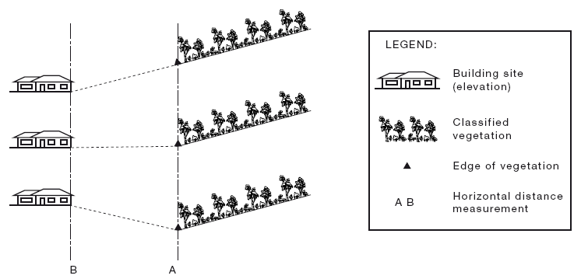

CLAUSE 2.2.5 Step 4 – Effective Slope of Land under the Classified Vegetation
‘Slope’ refers to the slope under the classified vegetation in relation to the building – not the slope between the vegetation & the building.
For each vegetation type classified in Clause 2.2.3, determine the effective slope (in degrees) of the land under the classified vegetation and whether it is upslope or downslope in relation to the site (see Figure 2.2).
Effective slope of land under classified vegetation is prescribed in degrees, approximate slope rations and percentages. As fire travels slower down a hill, all classified vegetation that is upslope will assume a value of 0º (i.e. flat land). Table 2.2 provides comparisons between degrees, slope rations and percentages.

C2.5 The slope of the land under the classified vegetation is much more important than the slope of the land between the site and the edge of the classified vegetation. The slope of the land under the classified vegetation has a direct influence on the rate of fire spread, the severity of the fire and the ultimate level of radiant heat flux.
For Method 1 it is not important to determine the slope of the land between the site and the edge of the classified vegetation (See Figure 2.1, Point B to Point A). The further the distance the less radiant heat reaches the site.
It may be necessary to consider the slope under the classified vegetation for distances greater than 100m in order to determine the effective slope for that vegetation classification.
Where the slope of the land under the classified vegetation is downhill from the edge of the classified vegetation nearest the site, it is considered ‘downslope’ regardless of the slope of the land between the site and the edge of the classified vegetation (see Figure 2.2).
Where the slope of the land under the classified vegetation is uphill from the edge of the classified vegetation nearest the site, it is considered ‘upslope’ regardless of the slope of the land between the site and the edge of the classified vegetation (see Figure 2.2).
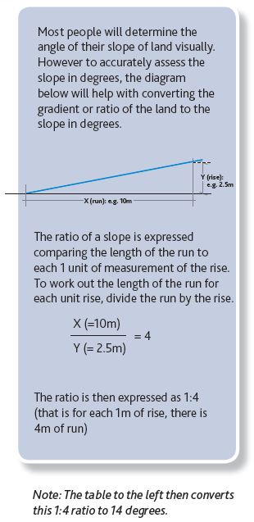
TABLE 2.2 – Slope Comparisons
Degrees | Ratio | Percentages |  | Degrees | Ratio | Percentages
45 | 1:1 | 100 |  | 7 | 1:8 | 12
34 | 1:1.5 | 66 |  | 7 | 1:8.5 | 11
26 | 1:2 | 50 |  | 6 | 1:9 | 11
21 | 1:2.5 | 40 |  | 6 | 1:10 | 10
18 | 1:3 | 33 |  | 5 | 1:11 | 9
15 | 1:3.5 | 28 |  | 5 | 1:12 | 8
14 | 1:4 | 25 |  | 4 | 1:13 | 8
12 | 1:4.5 | 22 |  | 4 | 1:14 | 7
11 | 1:5 | 20 |  | 4 | 1:15 | 7
10 | 1:5.5 | 18 |  | 4 | 1:16 | 6
9 | 1:6 | 16 |  | 3 | 1:17 | 6
9 | 1:6.5 | 15 |  | 3 | 1:18 | 5.5
8 | 1:7 | 14 |  | 3 | 1:19 | 5
8 | 1:7.5 | 13 |  | 3 | 1:20 | 5

FIGURE 2.2 – Determination of Effective Upslope and Downslope
Note: Effective ‘slope’ refers to the slope under the classified vegetation in relation to the building – not the slope between the classified vegetation and the building
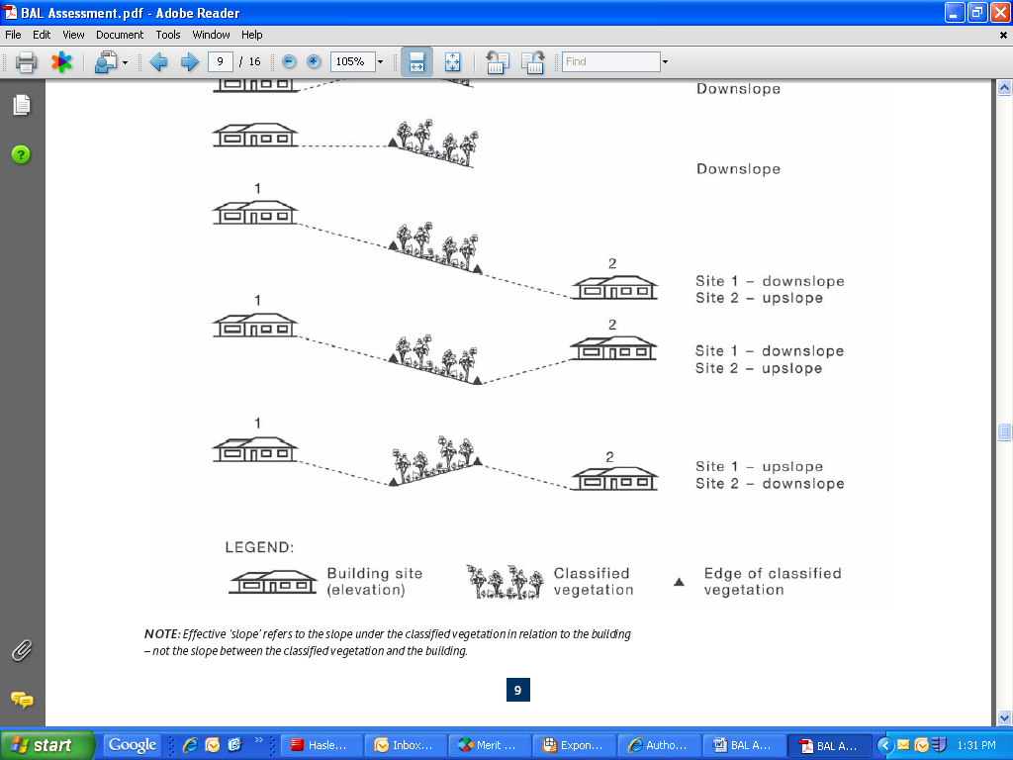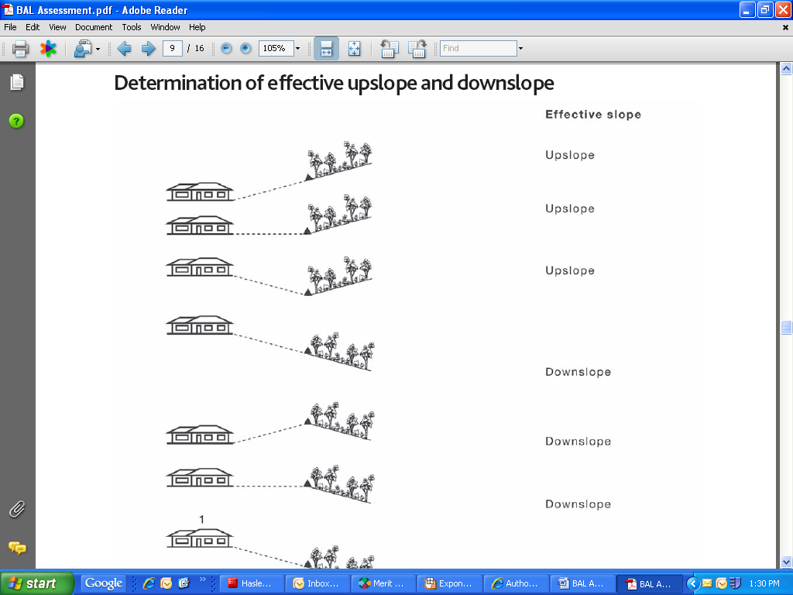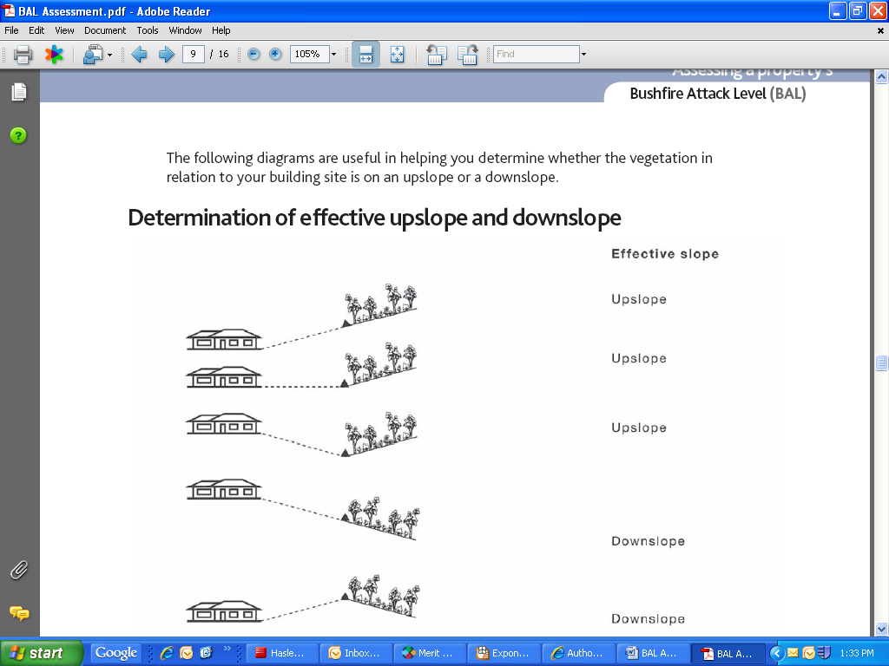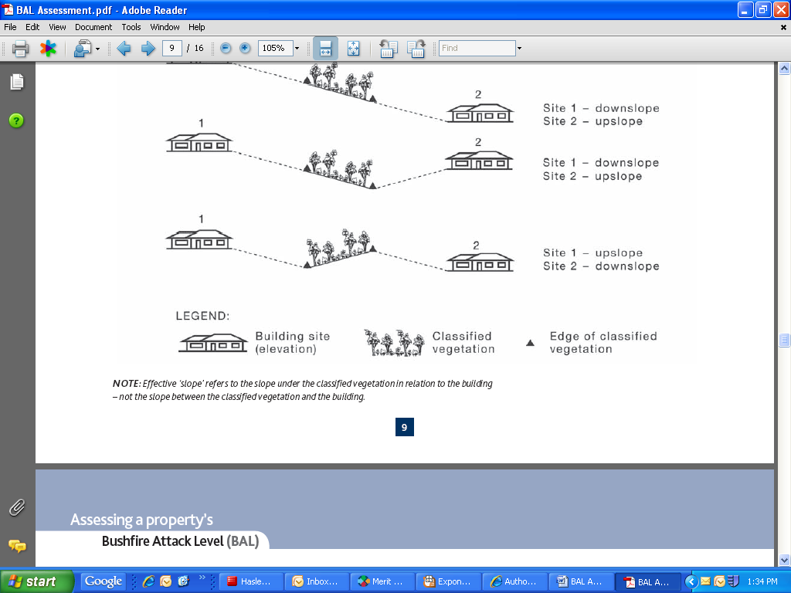

CLAUSE 2.2.6 Step 5 – Determination of Bushfire Attack Level (BAL)
The determination of Bushfire Attack Level (BAL) for a site using Method 1 shall be determined in accordance with the following:
- Select the relevant table from table 2.4.2 to 2.4.5 based on the FDI determined at Clause 2.2.2 (Step 1).
- Using the relevant table, determine the Bushfire Attack Level (BAL) for each of the vegetation classifications determined at Clause 2.2.3 (step 2), the distance from the site determined at Clause 2.2.4 (Step 3) and the effective slope determined at Clause 2.2.5 (Step 4).
- Select the highest Bushfire Attack Level (BAL) obtained from Item (b) above.
Notes:
- The determination in Tables 2.4.2, 2.4.3, 2.4.4 and 2.4.5 are based on input values contained in Table 2.4.1.
- A worked example of determining the Bushfire Attack Level (BAL) is shown in Appendix A and is based on inputs contained in Table 2.4.1.
- Where any of the input values contained in Table 2.4.1 are not appropriate for the site being assessed, the assessment should adopt the detailed approach given in Appendix B (Method 2)
TABLE 2.3 - Classification of Vegetation
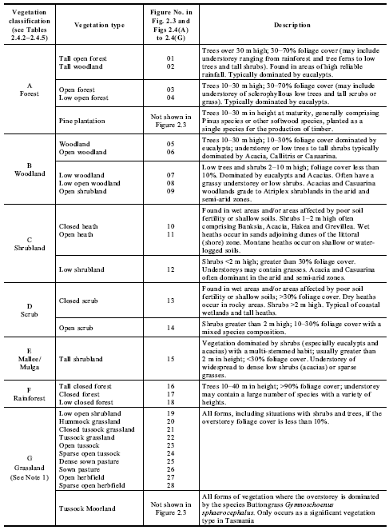

Notes:
- Grassland managed in a minimal fuel condition is regarded as low threat vegetation for the purpose of Clause 2.2.3.2.
- Overstoreys of open woodland, low open woodland, tall open shrubland and low open shrubland should be classified to the vegetation type on the basis of their understoreys; others to be classified on the basis of their overstoreys.
- Vegetation height is the average height of the top of the overstorey
FIGURE 2.3 – Classification of Vegetation - Summary
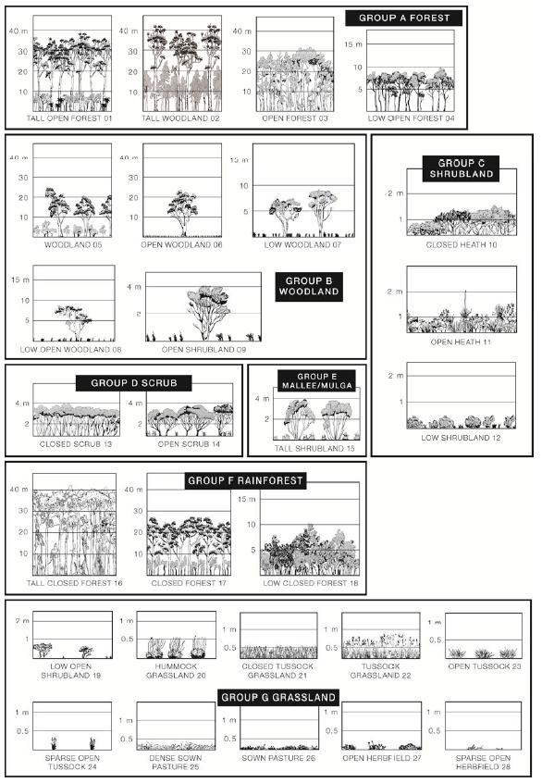

SITE PLAN - eXPlaNATION AND EXAMPLE:
The site plan may be an indicative plan and not to scale. However, the site plan should show all vegetation within 100m of the building and include accurate distances from the external element of the building to the classified vegetation. It should also show all exclusions considered under clause 2.2.3.2 and the distances (where relevant) between the excluded vegetation and other excluded vegetation or classified vegetation, and the distances to the building.

EXAMPLE ONLY:
22m
75m
20m
32m
98m
32m
23m
29m
Managed grassland
Open forest
105m
55m
Building site
Less than 0.25 ha, less than 20m width, ≥20m from site or other classified vegetation (see 2.2.3.2 (c) & (d))
Less than 0.25 ha, ≥20m from site or other areas less than 0.25 ha (see 2.2.3.2 (c))
Road (see 2.2.3.2 (e)
Vegetation more than 100m from site (see 2.2.3.2 (a)
Allotment boundary

TABLE 2.4.2 – Determination of Bushfire Attack Level (BAL) – FDI 100 (1090K)

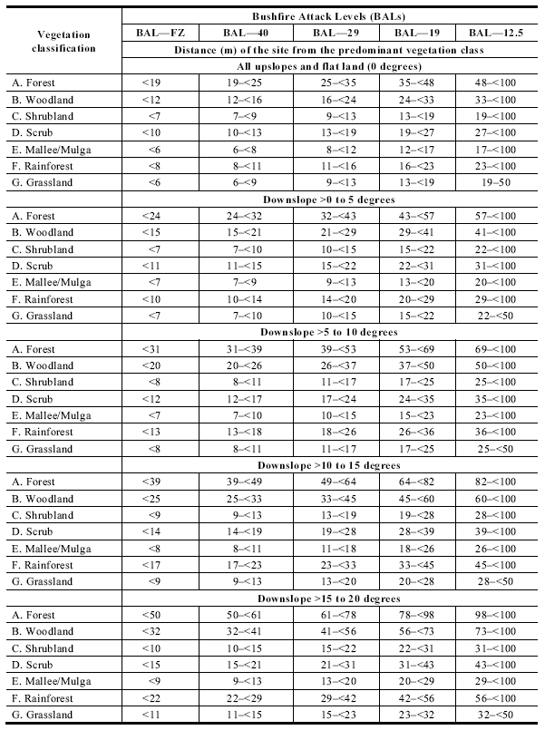
TABLE 2.4.4 – Determination of Bushfire Attack Level (BAL) – FDI 50 (1090K)

