
Accessibility Guide for Local Businesses

______________________________
Better Access,
Better Business



Hepburn Shire Council acknowledges the Traditional Custodians of the land on which we live and work, the Dja Dja Wurrung People, and pays respect to the wisdom of Elders past, present and emerging.
Introduction
There are many people with disabilities living in the Shire who access Council services and use Council facilities. Local Government is a key planner, developer and provider of the physical and social infrastructure and is predominantly placed to make an enormous contribution in protecting the rights of people with a disability and providing universal access.
Inclusion is a fundamental human right. Common access barriers to inclusion include communication, employment, transport, community attitudes, service capacity, affordability and the built environment.
Our Disability Access and Inclusion Plan brings together the successes of work undertaken through previous plans and links with Council’s other plans, policies and strategies.
One of the most important objectives of the Plan is to provide our local businesses with the needed resources to help them improve the accessibility of their businesses and see the benefits of employing people with a disability.
The Purpose of this Guide
As a small business or service provider, quality service and customer access are critical to the success of your business. This guide will help you understand how to improve access to your business and connect to a significant customer base that you previously may not have planned for or fully understood.
What is a Disability?
The term ‘disability’ typically includes an impairment of a physical, intellectual or sensory nature (eg, vision and hearing).
Impairment can be life long, acquired by accident or as part of the ageing process.
The Disability Discrimination Act (1992) defines ‘disability’ as any of the following: chronic medical condition (eg, cancers or neurological diseases), sensory disability (eg, vision or hearing), psychiatric or neurological disability, learning disability, physical disfigurement, the presence in the body of disease-causing organisms (eg, HIV) and short-term or temporary disability.



What is Good Access?
Good access is about making sure that anyone can use your business, eg, adults, children, teenagers, parents, grandparents.
Good access is about gaining more customers for your business with improved physical access and accessible information.
Good access is about people easily finding your business, either from the street or on the internet.
Good access means people can get in and move around easily.
Good access means that all your facilities (eg, toilets, fitting rooms) are large enough to be used easily by everyone.
Good access means you understand that different people may need some support in effectively using your business and services.
Good access is an attitude that says “We listen and we want your business.”

Good access considers design relating to buildings and facilities as well as advertising, information and communication systems.
Some challenging questions to find answers to, together…


Information
Is there a large-print shop number on the front of your premises?
Is all your advertising and promotional material in clear, easy to read font?


Safety

Are effective lighting and non-slip floor surfaces provided?
Are glass doors clearly marked to avoid accidents?
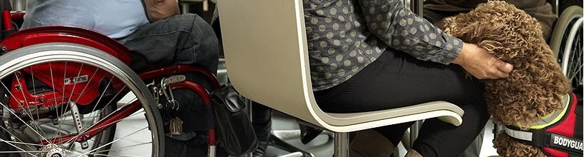

Is space provided for people to easily move around when using a pram, stroller, crutches, wheelchair, scooter or other mobility aid?
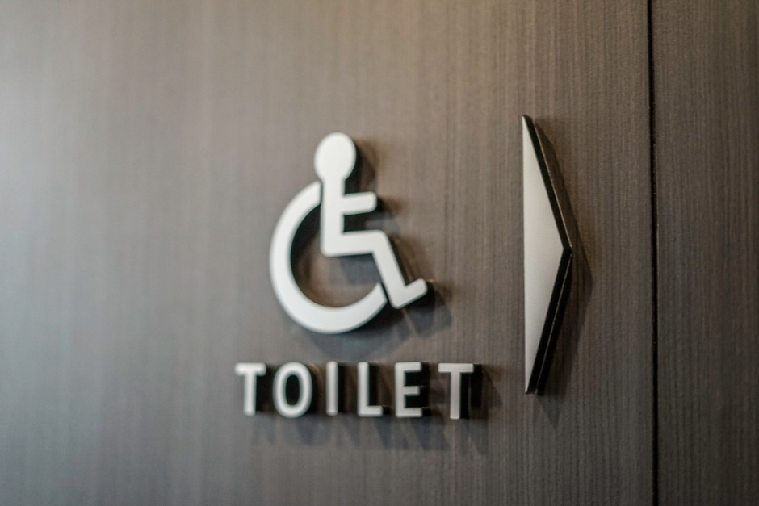

Facilities

Are facilities such as kitchens, bathrooms and fitting or change rooms able to be used easily by everyone, particularly a person who may be using a mobility aid or assistance animal?



Internal acoustics

Are noise-reducing elements, such as carpet, curtains or ceiling tiles used in customer service areas?
If there is background music, is it on a low volume to create ambience not annoyance?



Customer Service

Do your customer service staff know how to communicate effectively with people with a range of communication challenges or hearing or vision impairment?

Benefits of Providing Good Access
Did you know that more than 35% of the Hepburn Shire population are older adults who need accessible features?
There are many people who use a range of mobility devices such as prams, pushers and trolleys, who will benefit from good access to your business. All these people are potential customers. Each potential customer makes choices about your business based on how easy it is for them to access, as well as the quality and range of services provided and word-of-mouth recommendation from others.
By providing good access for all you are also meeting several legal and commercial requirements, including:
- reducing the likelihood of complaints being made
- opening your business to new markets and customers
- eliminating discrimination in a proactive way
- enhancing your business image
- supporting staff to work more effectively in delivering goods and services.
Good access benefits everyone, eg:
- parents or carers of young children, particularly those using a pram or pusher
- delivery people
- older people
- people recovering from injury
- shoppers with trolleys and heavy bags

What can you do to create a point of difference between your business and others?

What services and supports can you improve to gain that extra edge and earn your well regarded ‘word of mouth’ advertising?

Think about it ...

Improving access to your business can provide opportunities for increased patronage, membership, sales and business growth.
What the law says about access…

In Australia the law requires that people with disabilities and other access challenges should be able to access your goods, services and premises in an equitable and dignified manner, in the same way as all your other customers. If a customer with a disability, or older adult with access challenges, cannot get into your building or access the goods and services you provide, they could make a complaint under State or Federal legislation:
State – Victorian Equal Opportunity Act 2010
Federal – Disability Discrimination Act 1992

Making your business more access-friendly for everyone will improve safety for both customers and staff and will have a positive impact on your public liability and workplace safety responsibilities.
Disability Standards 2010
The ‘Disability (Access to Premises – Buildings) Standards 2010’ was introduced in line with an updated Building Code of Australia (BCA) on 1 May 2011. The Standards document was updated effective 30 September 2020. These are now legislated as the minimum requirements for new buildings and buildings undergoing significant upgrade in Australia.

Hints and tips
• accessible parking close to the premises
• accessible public transport close by
• accessible parking for motorised scooters & wheelchairs
• easy-to-see shop numbers
• clear external and directional signage, including symbols
• clear external building line at front of premises
• clear path of travel from outdoor to indoor areas
• wide, clear internal walkways
• protection from wind, rain and noise in outdoor areas
• step-free access
• wide self-opening or easy-to-open doors
• safety markings on glass doors and adjoining windows
• colour contrasting door frames/ trims
• low height service counters
• low pile carpet or slip resistant flooring
• seating with backs and arms
• recharge power point for electric wheelchairs/scooters
• ramp and lift access to all levels
• advertising good access features
• menus with large print for people with low vision
• an accessible website (WCAG 2.0 compliant) with information about your services, such as:
- online shopping
- home delivery services
- accessible payment options
- SMS services/options
- availability of an accessible toilet
- friendly, helpful staff trained in access awareness
- links to your social media pages.


Benefits of employing people with a disability
It’s increasingly likely that, to fill job vacancies with quality candidates, your organisation will employ people with a disability. Indeed, it makes good business sense to do so.

The business case for hiring people with disability is strong. There are real cost savings through reduced staff turnover and lower recruitment and retraining costs. What’s more, because people with a disability have fewer compensation incidents and accidents at work compared to other employees, insurance cover and workers’ compensation costs are often lower.

Employing people with a disability can also ensure that your team best reflects the community in which it operates. Like all employees, people with a disability bring a range of skills, talents and abilities to the workplace. They work in all sorts of jobs, with many holding tertiary or trade qualifications.

Some key facts about employing people with disability:
- People with disability generally take fewer days off, take less sick leave and stay in jobs longer than other workers.
- Employment costs for people with a disability can be as low as 13 per cent of the employment costs for other employees.
- Workers’ compensation costs for people with a disability are as low as four per cent of the workers’ compensation costs for other employees.
- Once in the right job, people with a disability perform as well as other employees.
- People with a disability build strong connections with customers.
- People with a disability boost staff morale and enhance a sense of teamwork.
- Hiring people with a disability enhances an organisation’s image in the general community.

Check Lists and guides
Cafes and Restaurants
Retail Outlets
Late Night Entertainment Venues
Tourism Services, Facilities and Venues
Hotels
Festivals and Events Check List
Accessible Events Guide
Policy and standards
Disability Discrimination Act
Web Content Accessibility Guidelines
Human Rights Commission - Access for all: Improving accessibility for consumers with disability
Other resources
Victoria Public Sector Commission Disability Employment Kit
Jobs Victoria Fund - for businesses hiring people with a disability

Contacts
Hepburn Shire Council
Postal Address: PO Box 21, DAYLESFORD 3460
PH: (03) 5348 2306
Email: shire@hepburn.vic.gov.au

Inclusion Officer
Brett Dunlop (working Tuesday, Wednesday, Thursday)
Email: bdunlop@hepburn.vic.gov.au
PH: 03 5348 2306
Mob: 0419 865 197

