Emergency Management Plan - *INSERT EVENT NAME*

*DATE   
LOCATION*

*TIME*

The following table will help you determine whether you need to complete an Emergency Management Plan. Please tick the most relevant boxes for your event below:

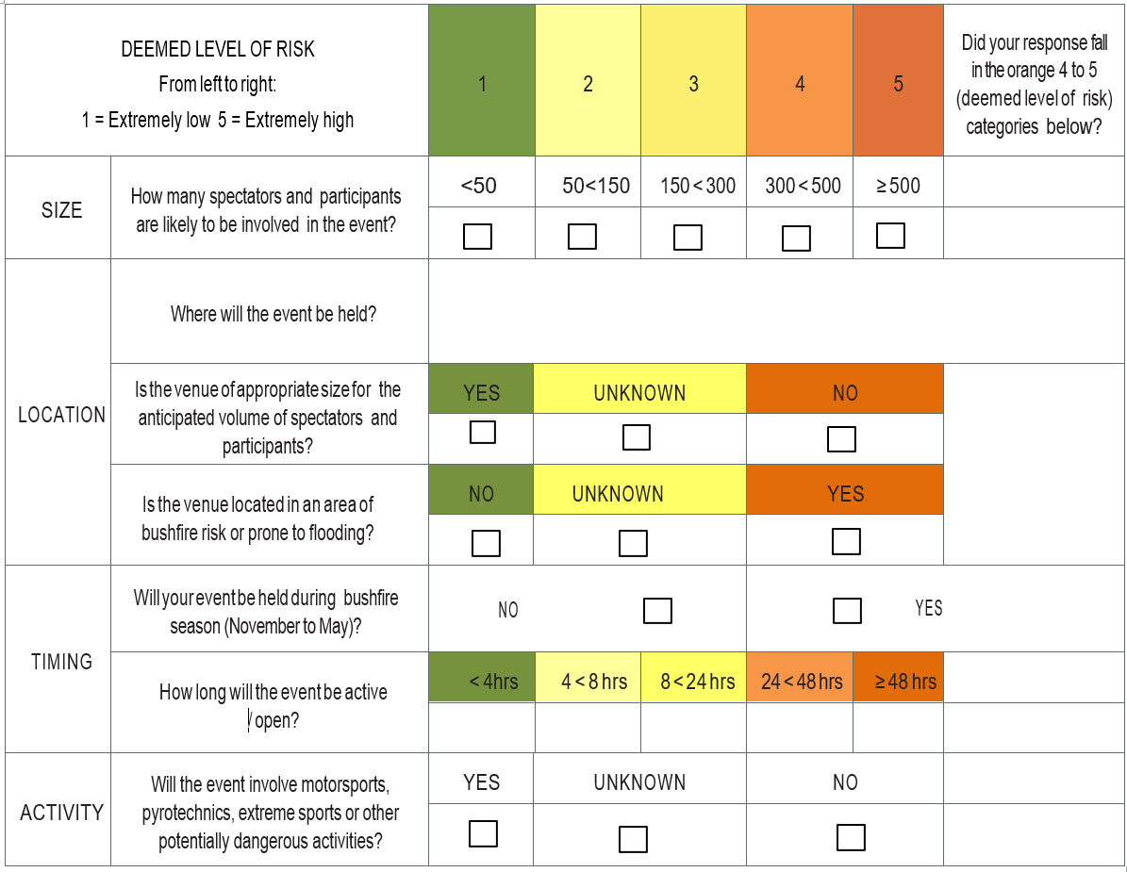

*If your event occurs across multiple venues, please complete the above table for each venue.*

If you answered YES in response to either of the following questions, please submit an Emergency Management Plan:

* Will your event be held during bushﬁre season?
* Is the venue located in an area of bushﬁre risk or prone to ﬂooding?

AND/OR

1. In the last column on the right, if you answered YES for two or more categories, please submit an Emergency Management Plan.

AND/OR

1. If you answered UNKNOWN for any category, please submit an Emergency Management Plan

**AMBULANCE, FIRE, POLICE - CALL 000**

Emergency Contact List

|  |  |  |
| --- | --- | --- |
| **TITLE** | **NAME** | **CONTACT NUMBER** |
| Event Manager |  |  |
| Chief Emergency Warden |  |  |
| Deputy Emergency Warden |  |  |
| Deputy Emergency Warden |  |  |
| Risk Management |  |  |
| Media Liaison |  |  |
| First Aid Officer |  |  |
| Staff/Volunteer Co-Ordinator |  |  |
| Stage/Site Manager |  |  |
| Mount Alexander Shire Council |  |  |
| Head of Security |  |  |

|  |  |  |
| --- | --- | --- |
| **TITLE** | **NAME** | **CONTACT NUMBER** |
| Police |  |  |
| Electricity |  |  |
| Gas Leak |  |  |
| Interpreter Service |  |  |
| Poison Information |  |  |
| SES |  |  |
| Water |  |  |
| St John’s Ambulance |  |  |
| Work Cover |  |  |
| Bureau of Meteorology (BOM) |  |  |

|  |  |
| --- | --- |
| **Name of Event:** | |
|  | |
| **Venue Address:** | |
|  | |
| **Event Organiser:** | |
|  | |
| **Date of Event:** | |
|  | |
| **Prepared By:** | |
|  | |
| **Date Prepared:** | |
|  | |
| **Emergency Plan Objective:**  Please provide a detailed description of any buildings, temporary structure. Provide a description of the intended use of the venue and event activities. Specify operating hours including bump in and bump out times. Estimate how many people will attend. | |
|  | |
| **SCOPE OF EMERGENCY MANAGEMENT PLAN** |  |
| Please specify the types of potential emergencies identified for the event. | |
| Medical Emergency |  |
| Fire |  |
| Flood |  |
| Storm |  |
| Wind |  |
| Hazardous Material |  |
| Gas Leak |  |
| Bomb threat/potential explosion |  |
| Armed or dangerous intruders |  |
| Suspicious items |  |
| Electrical failure |  |
| Lost Child/Missing Persons |  |
| Person Entrapment |  |
| Other more specific emergencies |  |

|  |
| --- |
| **EMERGENCY PREPARATION AND TESTING** |
| **Specify how emergency response personnel will be trained :** |
|  |
| **How will the organiser ensure all personnel, including stall holders and amusement operators, are aware of emergency management procedures?** |
|  |
| **How will you ensure electrical equipment, ﬁreﬁghting equipment, gas ﬁttings and other equipment (where relevant) are safe and eﬀective for use at the event?** |
|  |
| **Provide a statement that the emergency management plan will be reviewed immediately after the event (for recurring events only)** |
|  |

**EMERGENCY MANAGEMENT ROLES AND RESPONSIBILITIES**

Please identify the personnel who will be involved in an emergency response and their roles and responsibilities. Note: for large events additional roles to those listed below may be required.

Persons appointed to emergency response positions must be capable of performing the duties and be available at all times to undertake the duties. The chief Warden mist have the experience to determine the need for a total evacuation of the venue and should, preferably have formal training.

|  |
| --- |
| **CHIEF WARDEN** |
| NAME: |
| **RESPONSIBILITIES:** |
| * Assume initial control of the situation * Assess the situation and determine priorities * Activate the relevant emergency plan * Ensure the appropriate Emergency Service has been notified on 000 * Ensure Area Wardens are advised of the situation as appropriate * Nominate relevant personnel to meet and direct emergency services * Monitor the situation and ensure any action taken is recorded in the incident log * Liaise with external Emergency Services upon arrival * Any other actions as directed by the Emergency Services |
| **FURTHER RESPONSIBILITIES SPECIFIC TO THE EVENT:** |
|  |
| **SIGNED BY CHIEF WARDEN:** |
|  |
| **DATE:** |
|  |

|  |
| --- |
| **AREA WARDEN/S** |
| NAMES (list as many as required): |
| **RESPONSIBILITIES:** |
| * Receive directions from the Chief Warden and initiate appropriate action * Search areas to ensure all people have evacuated * Ensure orderly flow of people into nominated assembly areas * Assist occupants with disabilities * Report Status of required activities to the Chief Warden on completion |
| **FURTHER RESPONSIBILITIES SPECIFIC TO THE EVENT:** |
|  |
| **SIGNED BY AREA WARDENS:** |
|  |
| **DATE:** |
|  |

|  |
| --- |
| **FIRST AIDERS** |
| NAMES (list as many as required): |
| **RESPONSIBILITIES:** |
| * Collect First Aid Kit * Administer first aid as required |
| **FURTHER RESPONSIBILITIES SPECIFIC TO THE EVENT:** |
|  |
| **SIGNED BY FIRST AIDERS:** |
|  |
| **DATE:** |
|  |
| **ALL STAFF** |
| **RESPONSIBILITIES:** |
| * Carry out tasks as instructed by the Chief Warden * Proceed to assembly area advising all patrons to do the same * Remain in assembly area until advised by Chief Warden or Emergency Services Personnel that it is safe to leave. |
| **FURTHER RESPONSIBILITIES SPECIFIC TO THE EVENT:** |
|  |

|  |
| --- |
| **WARDEN IDENTIFICATION** |
| White- Chief Warden/Deputy Chief Warden Communication Officer    Yellow: Area Warden    Red: Warden |
| **WARDEN COMMUNICATION** |
| Please identify how wardens will communicate with each other. Consider having a code system in place such as prefacing your calls with:    Emergency – problem needs to be corrected immediately.   Top Priority – problem that has major and/or severe hazardous conditions.    Concern – problem that is less hazardous, but still represents a condition or concern to safety.    Preventative – problem with minimum danger to life, but correction will enhance safety. |

**IDENTIFICATION OF WARDENS**

Please detail how wardens will be identifiable. Helmets, caps, hats or vests may adhere to the following colour codes:

**EVACUATION OF YOUR EVENT**

Wardens are trained in an evacuation procedure specific for this event and are able to commence full or partial evacuation prior to assistance arriving.

The type of assistance will be entirely dependent on the situation and will be decided by the Chief Warden.

It is important that Emergency Services have been briefed on all aspects of your event

All Precincts are able to be evacuated separately or simultaneously depending on the event.

Evacuation Announcement

“You are not in any immediate danger, for your safety we need to stop the event temporarily and clear the area. Please assist us by following the directions of our wardens to the nearest safe exit”

|  |
| --- |
| **Please Identify your Emergency Assembly Area** |
|  |

Note: this must be clearly defined on your site plan.

The total evacuation of one or more of the event sites will in most instances be initiated by the Chief Warden or delegate via the Precinct Wardens.  On some occasions it may be necessary for the Precinct Wardens to self-initiate evacuation from the immediate area of a threat prior to notification from the Chief Warden.  It should be noted that the extent of evacuation might vary from one event to the next.

Evacuations fall into two categories:

**Full** resulting in all patrons and employees moving out of the event grounds;

**Partial** resulting in designated patrons and employees moving out of the event grounds, or being directed into another part of the event grounds.

The type of evacuation will depend on the nature of the emergency and will generally be determined by the Chief Warden or a delegate.

**DELEGATION OF DUTY**

If the Chief Warden is unavailable, responsibility will be delegated in the following sequence:

1. Deputy Chief Warden
2. xx
3. xx

**NOTE: Police and Fire Brigade out rank all event management. Should either give any personnel a direct order, they should carry out the order.**

**BREAKDOWN OF SAFETY EQUIPMENT AT YOUR EVENT**

|  |
| --- |
| **Please list all safety Equipment at your event (examples are provided)** |
| * First Aid kit * Fire Extinguishers * Sunscreen * Bottled Water * Barrier Tape * Safety Gloves * Syringe Disposal Container * Whistle * Loud Hailer * . * . |

Note: this must be clearly defined on your site plan.

**MOBILITY IMPAIRED PERSONS**

In the event of an evacuation Wardens should assist or arrange assistance for mobility-impaired persons. A mobility-impaired person is any person who will require physical assistance during an evacuation.

For Example: Permanent Disablement

Temporary Disablement

Deafness (full/partial)

Blindness (full/partial)

Advanced pregnancy

**WARDEN INDUCTION**

Please outline how you plan to train/induct your wardens to your event. It is important to include the following

1. Overview of event
2. Specific duties of each area warden
3. General duties/ evacuation routes
4. Radio procedure/communications

1. Understanding the safety plan
2. Incident reporting
3. Media management

|  |
| --- |
| **WARDEN INDUCTION PLANS** |
|  |

**STAFF AND VENDOR BREIFINGS**

Please outline your plans to communicate your EMP to your staff and vendors.

|  |
| --- |
| **STAFF AND VENDOR BRIEFING** |
|  |

**FIRE PREVENTION AND RESPONSE PLAN**

Please outline the potential sources of fire and actions to prevent fires. Include emergency procedures, a list of equipment and personnel in the event of a fire.

|  |  |  |
| --- | --- | --- |
| Potential Fire Source | Prevention and treatment options | Responsibility |
|  |  |  |
|  |  |  |
|  |  |  |
|  |  |  |
|  |  |  |
|  |  |  |
|  |  |  |
|  |  |  |
|  |  |  |
|  |  |  |

**Action when confronted by Fire:**

* Try to remain calm and think logically
* Alert all personnel to the danger calmly
* Cause the Fire Brigade and the Chief Warden to be advised
* Determine the type and extent of fire
* Select the correct type of extinguisher
* Use the extinguisher in the proper manner.  If in doubt, read the instructions
* Have another person back you with another extinguisher
* Keep a means of escape paramount in your mind
* Keep low to avoid heat, smoke and toxic gases
* Direct the extinguisher stream at the seat of the fire, not at the smoke
* Never use water extinguishers on fires involving electricity
* Turn off the power to the appliance or the area when the fire has been extinguished

**FIRE EXTINGUISHMENT INFORMATION**

Please detail which extinguishers you will have onsite for your event. NOTE: you will need to show these on your event site plan.

|  |
| --- |
| **EXTINGUISHERS ON SITE** |
|  |

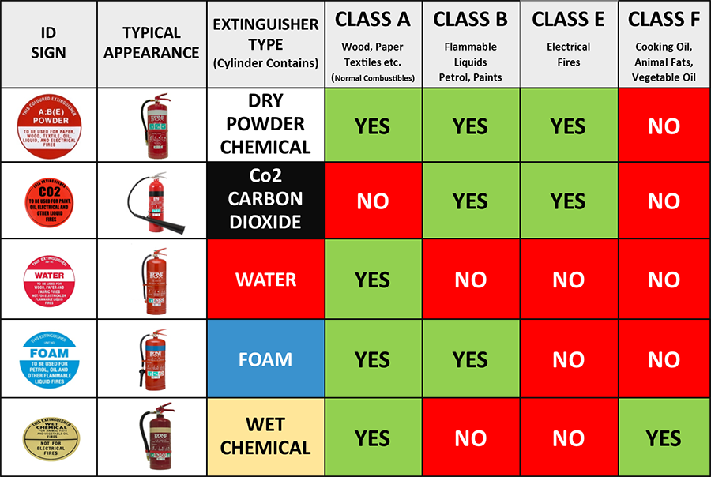

**Extinguisher Operation**: Each of the above extinguishers operates in the upright position.  The extinguisher should be carried to a safe distance from the fire.  Remove the safety pin, test and direct at the seat of the fire.  Be aware that a fire you think is extinguished may re-ignite without notice.  Never turn your back on a fire while still in close proximity.

Used extinguishers should never be replaced on their hook.  They should be reported to the Precinct Warden so that the extinguisher is recharged and/or replaced immediately.

**FIRST AID/MEDICAL EMERGENCY PLAN**

Outline the first aid or medical services in attendance at the event including numbers and type and outline the response to a medical emergency. NOTE: Please include the location of your first aid on your site plan.

|  |  |  |  |  |
| --- | --- | --- | --- | --- |
| **FIRST AID OFFICER/PROVIDERS** | | | | |
| **NAME** | **PHONE** | **EMAIL** | **ARRIVAL TIME** | **DEPARTURE TIME** |
|  |  |  |  |  |
|  |  |  |  |  |
|  |  |  |  |  |
|  |  |  |  |  |
|  |  |  |  |  |
| **FIRST AID PLAN** | | | | |
|  | | | | |

**CROWD CONTROL/SECURITY PLAN**

Outline crowd control and security plans, personnel numbers and their roles.

Include, if applicable, things like fencing, entry and exit points, security and age identity checks, restricting entry to those holding a valid ticket, a list or prohibited items displayed at entry, terms and conditions of entry advertised etc.

|  |
| --- |
| **CROWD CONTROL/SECURITY PLAN** |
|  |

**Provide details of professional security/crowd control companies (if using)**

|  |  |  |
| --- | --- | --- |
| **COMPANY** | **CONTACT** | **PHONE NUMBER** |
|  | | |

**WEATHER MONITORING AND RESPONSE PLAN**

If applicable, outline how you will monitor and respond to weather events that may impact your event (eg Extreme heat, wind, flooding etc)

|  |
| --- |
| **Weather Response Plan.** |
|  |

**EVENT CONTINGENCY – CANCELLATION OR POSTPONMENT PLAN**

Outline your event contingency plan it the event needs to be cancelled, postponed, relocated or interrupted on the day.

|  |
| --- |
| **EVENT CONTINGENCY PLAN** |
|  |

**EVENT SPECIFIC PLANS**

Include plans for any specific emergencies that may arise at your event. This can include such things as Lost Children, Safe Passage of Vehicles, Pick up and Drop off Points, Speed Limits

|  |
| --- |
| **EVENT SPECIFIC PLANS** |
|  |

**COMMUNICATION AND CONSULTATION DETILAS**

Outline who has been involved or consulted in developing your plan or giving any advice or information.

|  |
| --- |
| **EVENT SPECIFIC PLANS** |
|  |

**DAILY INCIDENT REPORT FORM**

Report any significant incidents (that impacts upon or has the potential to impact upon the safety of staff, participants or patrons)

|  |  |  |  |
| --- | --- | --- | --- |
| **DESCRIPTION** | **ACTION REQUIRED** | **TIME** | **OUTCOME** |
|  |  |  |  |
|  |  |  |  |
|  |  |  |  |
|  |  |  |  |
|  |  |  |  |
|  |  |  |  |
|  |  |  |  |
|  |  |  |  |
|  |  |  |  |
|  |  |  |  |
|  |  |  |  |
|  |  |  |  |
|  |  |  |  |
|  |  |  |  |
|  |  |  |  |
|  |  |  |  |
|  |  |  |  |
|  |  |  |  |
|  |  |  |  |
|  |  |  |  |
|  |  |  |  |
|  |  |  |  |

Shape**NO INCIDENTS TO REPORT**

**WARDEN:**

**SIGNATURE:**  **DATE:     /** **/** **TIME:**