Women’s Honour Roll 2010

Recipients:
- Sally Lea McRae
- Winifred Marigold Elliot (Meg)

Sally Lea McRae
At present, the information hasn’t been provided to Council on Sally Lea McRae will be updated as soon as possible.

Winifred Marigold Elliot (Meg)
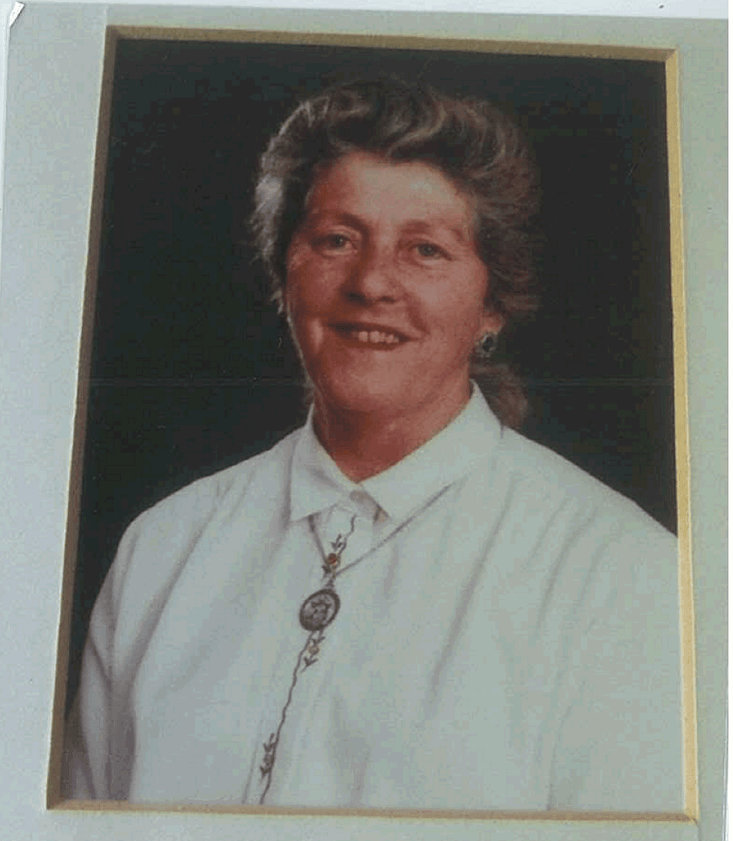
Along her life’s journey Meg’s feisty, forthright and independent personality has enabled her to achieve great things and to survive in the tough environment in which she has lived and worked.

Meg Elliott was born Winifred Marigold Graham on 1st March 1938. She was one of seven children from a humble, hardworking and tough Daylesford family of pioneering stock. Meg was educated in Daylesford. When her family moved to Warragul she trained as a Secretary. It was here that Meg met, and married Tom Elliott and they moved to Croydon and had two children. As a working mother during the 1960’s, Meg had various jobs which included driving taxis and delivering bread. In the 1970’s Meg returned to Daylesford; a single mother with her 13 year old daughter Phyllis and settled at Coomoora. With the help of Phyllis, she ran a small farm – baling hay, fencing, driving farm machinery and chain sawing wood, chopping and carting wood. Her older cousin, Joyce, was in awe of Meg’s skills and confidence as she carried out the ‘work of men’.
She also trained and qualified as a meat inspector becoming Victoria’s first female meat inspector. Working in a tough and male – dominated industry was not without its challenges and obstacles. She described these to a group of over 200 women at a ‘Women In Action’ Seminar around 1990 at the Daylesford Town Hall. Meg became active in local politics and community life. In the 1980’s she became a Councillor with the then Daylesford and Glenlyon Shire. She became the Shire’s second female Mayor and would serve two terms as Mayor (1989-1990). These were tumultuous times in Victorian Local Government leading up to forced amalgamations. As Mayor she also became a Justice of the Peace (J.P).

It was around this time Meg’s struggle with rheumatoid arthritis began. But, despite her increasing disability, she retained her independence and activity in community life. She used her skills and knowledge gained as a Councillor for the benefit of community causes e.g. Daylesford & District Action Group (DDAG), Senior Citizens, Hepburn Community Access Group and VCAT planning appeals. Meg was instrumental in lobbying for disability access to public places and spaces e.g. the Daylesford Town Hall and street spaces. In 2009 Meg suffered a serious stroke and sadly was unable to return to her much – loved home overlooking Slum Dam in Daylesford. She moved to a nursing home in Benalla where her daughter and family live.

