Women’s Honour Roll 2013

Recipients:
- Susan Dennett (Su)
- Nettya Tulku-Rose

Susan Dennett (Su)
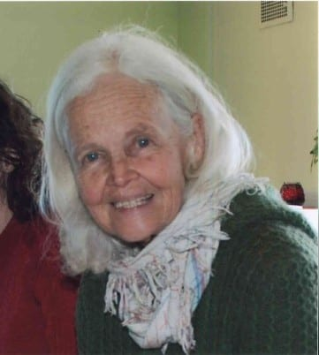
Community leader Su Dennett was cited for constantly offering encouragement for women and their families to work towards an ecologically sustainable self-sufficient life.

Su Dennett is a local elder, teacher, publisher, and sustainability mentor. She is described as “a tireless worker towards a fairer and safer community and as a stalwart when it comes to social justice, especially concerning the rights of women and enabling better opportunities for local women and their families to access healthy food”.

Su is a fierce campaigner for environmental justice and is considered both a local and global pioneer of the permaculture movement. Su’s life has been dedicated to how we can better work to achieve harmony with the land and with each other. Su co-founded Hepburn Relocalisation Network in 2005, which regularly hosts information sessions, workshops and film nights focussed on sustainability and the associated skills required to pragmatically implement sustainable living modes within our shire.

These skills range from her extensive knowledge in animal husbandry, organic gardening, harvesting, preserving, ecological restoration, all things that Su shares daily with her community. Her work in networking local families to local farm produce has enabled many local families to eat best practice agricultural food at affordable prices. This has helped grow the burgeoning community food system, a system that recognises food miles as an enormous contributor to climate change, and Su has worked closely with community gardeners to further expand a local and just food economy. Su has been an active member of Council’s sustainability group and worked with Council and fellow community participants to establish the Shire’s Energy Descent Action Plan, a first of its kind in Australia.

Nettya Tulku-Rose
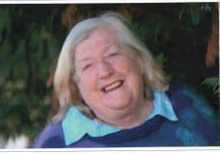
73 year-old Tulku-Rose worked for many years in Hepburn Shire as a teacher, and as a successful business woman. She was commended for advancing the status of women both here and overseas.

Among her numerous and significant contributions, Tulku- Rose has volunteered her time and skills to assist the plight of women and girls in South Africa, Kenya, locally in Daylesford, and other places for many years.
Tulku Rose is well known in Hepburn. As a pioneer, she was the first ordained female minister in the region, as a person of compassion, opening doors to women for meditation and counselling and starting a nursing mothers meditation group, and as a ‘can-do’ person, with friends, she started the Central Highlands AIDS Support Group.

She recognised the poor status of women in South Africa and worked to provide them with sustainable employment and business opportunities through Emily Jordan House, and organised the donation of sewing machines to a girls’ school.

Tulku-Rose has been described as “a force for great good in the Daylesford/Hepburn Springs Community and a wonderful example of service above self.”

