Women’s Honour Roll 2025

Recipients:

* Mary-Faeth Chenery
* Lynda Poke
* Mary Harvey
* Jessie Leggatt (Posthumous)
* Donna Kelly

**MARY-FAETH CHENERY: Advocate for Women's Leadership and Housing Security**

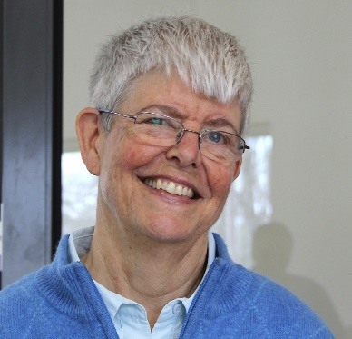Mary-Faeth is a distinguished representative of Australia at numerous international events organised by the Global Peace Initiative of Women, where she has worked diligently to elevate the representation of women in peace negotiations. This initiative harnesses the insights of global spiritual leaders to empower young individuals in addressing critical environmental and peace-related challenges.

As a co-founder and current president of Older Women in Cohousing (WINC), Mary-Faeth has made significant strides in addressing the housing security needs of older women, particularly older lesbians. Under her leadership, WINC is developing a project that will provide 31 new, small, sustainable, and accessible homes within a mutually supportive community. Since 2017, she has collaborated closely with her co-founder to establish the organisation, acquire property, foster a community of older women, and secure planning permission for this innovative ‘village.’ Mary-Faeth's vision extends beyond merely creating secure housing for those who can afford it; she is committed to ensuring that older women experiencing financial hardship also can live with dignity and agency.

Additionally, Mary-Faeth is a founding member and current president of Safe Place Homes, an incorporated society dedicated to alleviating housing challenges within the Shire and beyond, particularly for vulnerable populations, including older women facing financial difficulties and those escaping domestic violence.

Prior to her current voluntary roles, Mary-Faeth served as the head of the Department of Outdoor Education and Nature Tourism at La Trobe University Bendigo, where she inspired students—especially young women—by modelling leadership and supporting them in discovering their own strength and courage to reach their full potential.

**LYNDA POKE: Advocate for Gender Equity and Community Health**

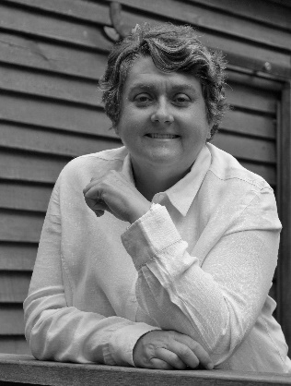Lynda is an exceptional advocate for gender equity and equality, dedicated to enhancing access to essential services, including General Practitioner care, for all members of the community. She possesses a wealth of expertise in budget and financial reporting, board secretarial services, the development and implementation of strategic and business plans, HR policy management, business development, project management, risk management, and general practice accreditation.

Leveraging her extensive skills, Lynda has provided invaluable voluntary support to several local community organisations. She served as a Board Director for the Daylesford Neighbourhood House and the Dharma School Daylesford for three years each. Additionally, her role on the Hepburn Shire Diversity and Equality Advisory Committee ensured that gender equity remained a central focus in community planning and inclusion. Lynda played a pivotal role in establishing Health Futures Australia, a local health promotion charity and social enterprise, over a five-year period. She contributed essential start-up services that enabled the organisation to operate the Healthy Lunch Kitchen, providing nutritious meals to six local schools.

As General Manager of Springs Medical Centre for nine years, Lynda was instrumental in developing a thriving General Practice, introducing innovative services such as the “Spring in Your Step” lifestyle modification program for high-risk community members. Under her leadership, Springs Medical Centre was recognized as the Victorian General Practice of the Year by the Royal Australasian College of General Practitioners (RACGP) in 2018.

Lynda consistently demonstrates outstanding community leadership, particularly in advocating for at-risk and vulnerable populations, including women and children. Her voluntary contributions of financial, governance, and operational expertise to local charities and non-profit organisations are a testament to her commitment to community well-being.

Notably, Lynda co-led a grassroots effort challenging the Victorian Liquor Licensing Commission regarding a new liquor outlet in Daylesford. This initiative, which spanned several years, aimed to protect vulnerable community members, especially women and children, from the potential harms of alcohol-related issues.

Through her tireless efforts in both voluntary and professional capacities, Lynda inspires others, particularly women, to lead and govern with strength, compassion, and conviction. She is a trailblazer in the business and finance sector, specialising in support for small businesses and community organisations, an area traditionally underrepresented by women who have often had to work harder to forge their paths.

**MARY HARVEY: A Role Model and Community Leader**

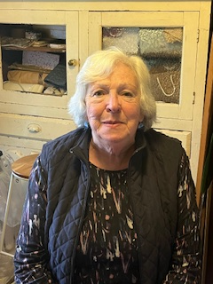As the female Head Prefect of Ouyen High School, Mary Harvey served as a pivotal role model for the girls in her school, exemplifying the value of education as the only graduate of Form 6. Her commitment extended beyond her own achievements; she was a dedicated member of the Technical Schools Library Standing Committee and the Vice President of the School Library Association of Victoria.

Later, as a Publicity and Publications Officer in the Westernport Region, Mary advised principals on effective school promotion and prepared materials for visits from ministers and the Premier. Mary's community involvement continued with the Spa Quilters of Daylesford, where she has actively promoted the skills and work of its members through materials she prepares for their biannual quilt shows, serving on the Committee for the last four events. Her leadership qualities shone through as Secretary of the Bullarto Public Hall Committee, where she worked to foster community spirit in a group previously dominated by longterm male residents resistant to change. Under her influence, the Hall Committee now enjoys gender equity and is focused on becoming a central hub for the community.

In her role as a member of U3A, Mary played a crucial part in initiating the highly successful 14th July fundraiser for the Daylesford Community Brass Band, which has become a cherished annual event. As a former French teacher, she launched a French class for U3A and co-founded Le Cercle Français, a vibrant group of Francophiles that has flourished for over eleven years.

With a background as a qualified librarian, Mary shared her expertise by cataloguing numerous books and maps for the Daylesford Museum and managing the library for Spa Quilters for a decade.

Mary's skills as a Publicity and Publications Officer were instrumental in editing the “100 Years of Daylesford Gold Mining History” for the Daylesford Museum, and she has compiled the 22-page schedule for the annual Daylesford Show since 2018. As a teacherlibrarian, she encouraged library staff to pursue further qualifications, with one assistant successfully achieving her degree and securing a better position in a local private school. Additionally, as a library consultant, Mary organized in-service courses aimed at empowering primarily female staff to enhance their skills and take on leadership roles in schools.

The first in her family to attend university, Mary faced the challenges of single parenthood for eight years while raising two daughters, both of whom obtained university degrees. One of her daughters is now a Director of EAL at Cheltenham Secondary College. Mary's commitment to community and education has not only transformed the organisations she’s involved with but has also set a powerful example for future generations. Through her initiatives and leadership, she has fostered a sense of belonging and collaboration in Daylesford, leaving a lasting impact on her community.

**JESSIE LEGGATT (1825–1907): Pioneer of Philanthropy and Community Leadership**

Jessie Leggatt was a remarkable philanthropist whose contributions significantly shaped the Daylesford region and beyond during a time when women had limited opportunities for influence. Born in Scotland, she emigrated to Australia with her husband, Neil, during the gold rush of the 1850s. The couple established a successful storekeeping and gold- buying business, and in 1865, they built Leggatt’s Hotel and Store, a Daylesford landmark that remains standing today.

After Neil’s untimely death at the age of 45, Jessie became the sole beneficiary of his substantial estate. Outliving her husband by 37 years, she chose to dedicate her life to philanthropy, demonstrating a deep commitment to her community, education, and her Presbyterian faith. Although she preferred a quiet existence and “shrank from publicity,” her generosity was well-known. The Daylesford Advocate noted her “large-heartedness,” stating that a case of hardship would elicit a liberal gift from her.

Jessie’s most notable contributions included £1,700 for the construction of St Andrew’s Presbyterian Church, where she laid the foundation stone in December 1903. This significant donation was recognized in the press, with reports highlighting her commitment to ensuring the church was opened free of debt. Upon her death, she left an additional £2,500 to the church, along with bequests of £250 to the Daylesford Hospital and £1,000 to the University of Melbourne. The latter established the Jessie Leggatt Scholarship Fund, which continues to support legal scholars and has awarded scholarships to notable figures, including former Prime Minister Robert Menzies.

In her personal life, Jessie cared for Alfred Beckett, a young man considered her adopted son, who became a respected local councillor. His untimely death in his 30s was a significant loss for Jessie, further highlighting her resilience. Despite these challenges, she skilfully managed a large portfolio of property, demonstrating her acumen in an era when women had limited agency.

Jessie Leggatt’s philanthropy not only enriched her community but also established her as a pioneering figure in a male-dominated society. Her decision to create a scholarship fund in her own name was groundbreaking, setting a precedent for female benefactors. Today, her legacy endures as a testament to her unwavering commitment to community, education, and the empowerment of women.

**DONNA KELLY: Champion for Women in Media and Community Leader**

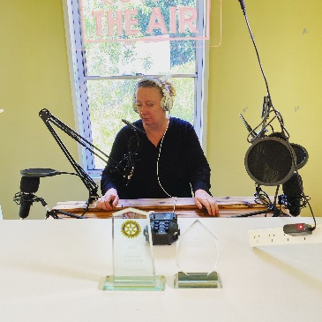Donna Kelly has consistently challenged the status quo in media, breaking down barriers for women to play vital roles in journalism. Beginning her career as one of the youngest female newspaper editors in Victoria, she has dedicated her life to providing a platform for writers of all ages through her publication, The Local. A strong advocate for gender equity, Donna has focused on highlighting the stories of inspiring women in the community.

Despite facing significant personal hardships, including the loss of her father at a young age and her mother during the pandemic, Donna has demonstrated remarkable strength and resilience. Throughout these challenges, she continued to publish The Local weekly, showcasing her dedication to her community.

During the COVID-19 pandemic, Donna made the courageous decision to keep The Local running despite a drop in advertising revenue. Rather than reducing its frequency, she opted to publish weekly and funded the operation from her own savings. Understanding the needs of an ageing population and those with limited access to information, she prioritised keeping the community informed about vital health updates and resources. Donna also took the time to profile frontline workers, acknowledging their contributions during this critical time.

Her commitment to community service extends beyond journalism. Donna has been involved with various local organisations, serving on committees for events like the Glenlyon Fine Food and Wine Fayre, GlenFest, and the Hepburn Wildlife Shelter Fundraising Committee.

Donna’s journalistic journey spans over three decades, with roles at various prominent publications, including the Cairns Post and Courier Mail. However, it was her love for the Hepburn Shire community that led her to create The Local with her partner, Kyle. This publication has become a vital source of positive news, helping to unite the community through shared stories.

Through her work, Donna has provided a platform for addressing challenging issues and has been transparent about her own struggles with mental health, inspiring many readers across Australia. She has also launched a free local podcast to connect the community during the pandemic, featuring insights from health professionals and local organisations.

Donna Kelly’s resilience, leadership and unwavering commitment to journalism, community, and mental health advocacy have made a lasting impact on the Hepburn Shire, solidifying her role as a vital community figure

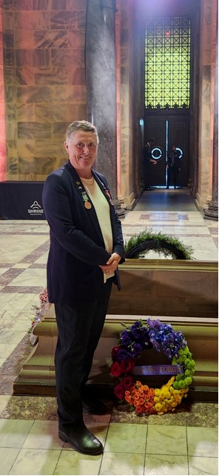**YVONNE SILLETT**

Yvonne's journey as a trailblazer began in 1979 when she enlisted in the Australian Army, breaking barriers in a male-dominated field. Despite achieving the milestone of becoming the first female corporal responsible for training recruits at Kapooka, her career was abruptly halted due to discrimination based on her sexuality. Undeterred, Yvonne embarked on a mission for justice, advocating for an apology from the Australian Government and Defence Force for the unjust treatment of LGBTQIA+ personnel. Her story gained recognition at the Victorian Shrine of Remembrance and in the book "Serving in Silence," showcasing her resilience and advocacy. Yvonne's voluntary testimony at the Government Royal Commission into Defence and Veteran Suicide further amplified her cause, aiming to empower LGBTQIA+ individuals serving in the Defence Forces. She remains committed to inclusivity and equality, advocating for LGBTQIA+ rights within the Hepburn Shire community and supporting initiatives like the Rainbow Wreath ceremony for Anzac Day. Yvonne's educational efforts extend to fostering awareness and understanding of LGBTQIA+ needs at Hepburn House and securing grants to support LGBTQIA+ elders in the community. As a co-founder of the Discharged LGBTQI+ Veterans Association, Yvonne continues to advocate for justice and recognition, inspiring others through her compelling story. Her unwavering commitment to authenticity and advocacy has sparked artistic tributes and invitations to speak at various events, solidifying her role as a champion for inclusivity and equality in both local and broader communities.