Event Management Toolkit
Volunteer Briefing Template

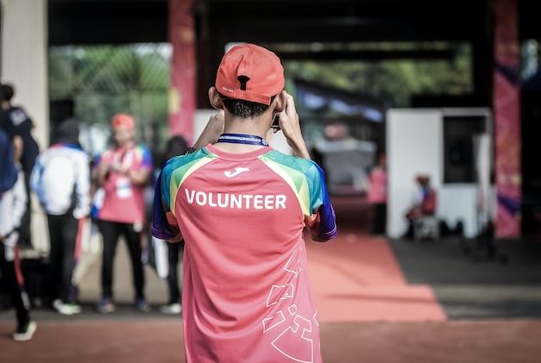

Dear [Volunteer Name]

Well, the countdown is on, the final finishing touches are being made and it is full steam ahead to the [Your Event, date, times] – Can you believe it’s here already?!
Thank you so very much for your generous offer to volunteer during this year’s event. We could not stage this wonderful event without our incredible team of more than [50] volunteers. It’s an amazing community achievement. Thank you once again!
The following letter contains important information regarding where you have been allocated to help on the day of the event. Please take the time to read it carefully and contact me, the Volunteer Coordinator should you have any queries. You will find my contact number at the end of this letter.
On Event Day you have been rostered on as follows:
[Name]
Time: [8:00am – 11:00am]
Area: [The Main Gate (involves handing out brochures, welcoming people to the event, overseeing the gold coin donation drum)]
Coordinator: [Name – Contact Number: (Number)]
A few important points for you to remember for Event Day:

Site Map
Please review a copy of the site map prior to Event Day on the event website: [link] Please find your allocated area and make your way to that spot around 10 minutes prior to your allocated start time.
Sign In and Sign Out
We need to keep a record of volunteers on the day. For this reason, you will need to sign in when you arrive at your area and sign out at the end of your shift. Please see your Coordinator when you arrive and they will direct you to the sign in point as appropriate. [Signing in and out also puts you in the draw for a major prize which will be drawn at our end of event BBQ!]
Change of Plans
If you think you may be late, or have to leave early, or are unable to attend at all on Event Day, please let me know as soon as you know. I am here to help, and I understand that sometimes things happen. You can call or text the Volunteer Coordinator at any time.
Water, Hats & Sunscreen
Stay hydrated! Be sun smart! Make sure you look after yourself.

Breaks
We’ll all need some time out during the day. This year we have tried to ensure that each area has ample hands on deck allowing you to enjoy the Event too! If you have been rostered on to a section for three or more hours, please talk to your Coordinator about when you would like to have a break. And please make sure you take a break! If you have any concerns on the day, feel free to contact the Volunteer Coordinator at anytime.
Bring this letter and the site plan with you on the day so you don’t get lost!
And finally, but MOST importantly…
We will be holding a very casual BBQ at the end of the event, starting around 5:30pm-6pm to say thank you to all the volunteers for helping us on the day. We would love you to be there! It is a great way to wind down from the day, have a laugh and share stories.
Well, that is it from us for now. Please call or email us if you need to clarify any of the above.
We look forward to seeing you on [event date]!
Kind regards,

[Name]

[Phone]

Volunteer Coordinator

