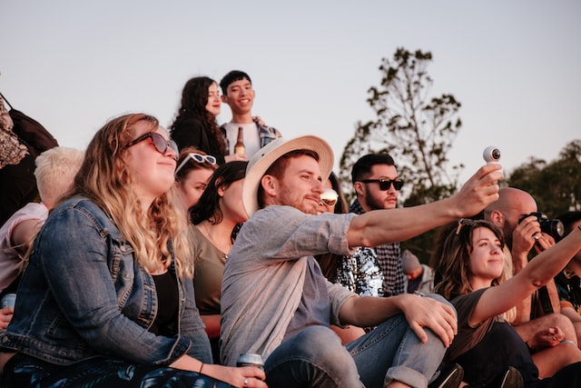
Event Management
Toolkit
Ideal Attendee Personal Template

IDENTIFYING YOUR IDEAL EVENT ATTENDEES
There are certain people you want to see more of at your event – the most profitable attendees who adore your event and talk about it and leave positive reviews about it on social media. They become advocates and promote your event for you!

💡 TIP: Identifying your Ideal Event Attendee helps you identify your ‘Target Markets’

WHO ARE THESE IDEAL ATTENDEES?
Ideal customer profiling helps you understand who they are, so you can focus your marketing activities (and program development) on attracting more of these kinds of visitors.
Basically, personas are fictional, generalised characters who represent the needs and behaviours of your ideal attendees, helping you to better understand your visitors. They define their common behaviours, pain points, wishes, and general demographic and biographic information.
You might come up with a couple of different ideal attendee personas, such as a twenty-something student travelling for the summer, a couple on a self-driving weekend break, a parent with his very young kids, a retired couple on a tour around Australia who are travelling with a little dog and require accessibility now they are a little less mobile, luxury brand shoppers, keen fishermen, food and wine lovers, escapists/adventurers – even the hosts of visiting friends and relatives!
HOW DOES KNOWING OUR IDEAL ATTENDEES HELP US?
Having someone clearly in mind when you’re planning marketing activities will help you make sure that you’re hitting the mark, and planning to get the most bang for your marketing bucks. Customer profiling helps you to intimately understand the disposition and emotional reasoning of a single person who represents your perfect attendee, and how they experience travel and events, so that you can attract (and delight!) more of the people you want to come to your event.
Personas help identify audience needs, wants and pain points that will inform and guide the marketing content you create and share on various channels and its tone, whether that is blog articles, images, videos or Facebook posts.
Now that search engines are based on semantic search, search engines are trying to ‘understand’ what your event represents. When you are consistent in what you’re saying and who you’re talking to in your marketing, then search engines will know ‘who’ your event is and be confident to present your event in a search.
THE PROFILING PROCESSES
You probably know a lot about your ideal customers already, and probably more than you think – their lifestyles, attitudes, interests, internet habits, purchasing habits, where they live, where they travel, what’s important to them in life, what they are seeking (to educate themselves, rest, connect with their families, or get immersed in your culture). Do some brainstorming and take some notes in the table below.
Now talk to your visitors face to face and ask them what they’re interested in.
Send a survey out to previous attendees (Don’t be afraid to: it shows you are trying to improve your event to suit them, and that you care about their needs and putting on a quality event.)
Listen to chatter about your event and its theme on social media.
Research with Google on statistics for your niche market/s and their preferred social media platform.
Use your website’s Google Analytics to find out information on your website’s visitors: where they live, types of devices they’re using, and what keywords they’re searching for.
PERSONAS WORKSHEET
ABOUT | THINGS TO THINK ABOUT | PERSONA 1 | PERSONA 2
Demographics | Residence  Age  Gender  Children (ages)  Marital status  Income  Education  Photo + fictional name
Profession | Job title/role  Career path  Special skills  Tools they use  Do they manage others?  How do they measure success?  What do they value in their professional life?  Career goals
Interests | What are their hobbies?  What gets them excited?  Where do they spend their days?  What are their attitudes?  What are their lifestyle choices?

ABOUT | THINGS TO THINK ABOUT | PERSONA 1 | PERSONA 2
Travel habits | Who do they travel with?  Where do they travel?  What questions do they have when planning travel?  What emotions do they have when planning travel?
Travel Cycle questions (this will help you plan content such as blog articles) | What questions does your ideal customer ask when they are:  - dreaming about travel  - planning travel  - booking travel  - pre-travel  - in-destination  - post-travel | e.g Which are the most dog-friendly Northern Rivers campgrounds?
Values & Fears | What do they value in their personal life?  Why do they value that?  What are they seeking (physically and emotionally)?  What’s important to them when considering a product/service like yours?  What objections might they have?  What drives their decision-making process?
Goals & Challenges | What are their personal goals?  How do they prioritise goals?  What are their motivations?

ABOUT | THINGS TO THINK ABOUT | PERSONA 1 | PERSONA 2
Pain points | What are their frustrations?  What barriers do they have to achieving goals?  What pain point could you solve for them?  How could you help them?
Communication | How do they get info?  How do they communicate?  What social do they use?  Internet habits  What are their social media habits?
Brands they like | What are the major brands they follow?  What is it about the brands that they resonate with?  What are their purchasing habits?
WHAT’S NEXT?
Do some experience matching with your ideal attendees by ensuring your offering matches what they want and what they need.
How can your event committee help your ideal attendees? How can you help them with their family-friendly holiday, or how help them unwind, or help them experience the best of food and wine in your town, or help them gain local knowledge and get immersed in the local culture?
Make sure to take actions that ease the pain points of your ideal attendee, so these particular people feel your event and destination would be a good match for them.

HOW TO MARKET TO YOUR IDEAL ATTENDEE
Use key messages that relate directly to what your ideal attendees is looking for. Have plenty of content on your website, social media and other communications around the fact that they can bring pets, or there is a gourmet local food experience where attendees can meet the producers, or whatever will tempt your ideal attendee. For example, for attendees who want to learn, emphasise the opportunities to gain insights during your event, such as learning from experts, getting a look behind the scenes, learning how something is produced, and meeting local characters. What can people learn from you that they can't learn elsewhere?
If your ideal attendee is not on Twitter, then you don’t need to invest time in Twitter. But if they are following a particular influencer on Instagram, consider how you can work with that influencer!

