Event Management
Toolkit
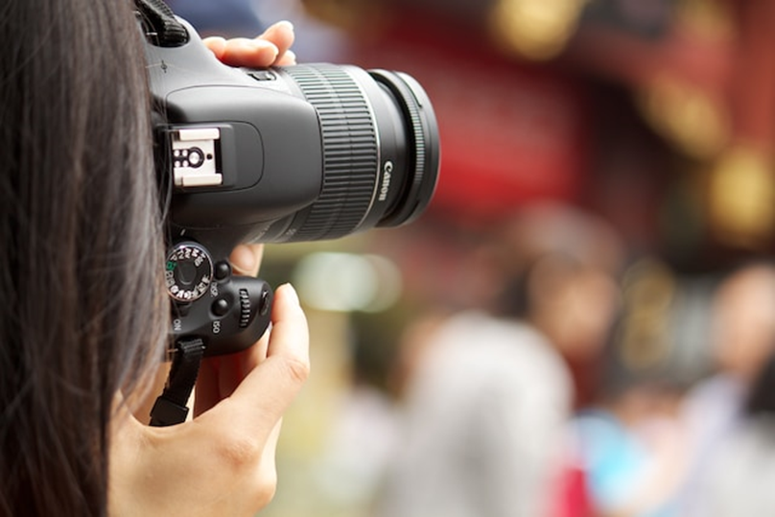
Media Famil Itinerary Example #2

[Your Logo]

Welcome to [Your Event]
[your website address]

PARTICIPANTS:

 | First Name | Surname | Position Title | Representing | Contact
1
2
3
4
5

[Your Event] Trail

EXAMPLES IN TEAL
Take a deep breath. Stop. Smell the roses, or in this case, the fresh country air as we take a leisurely weekend tour of some of the food names of the [Your Event Location]. Immerse yourself in the delights of the country – fresh produce, stunning landscapes, and real country living. As we set off from Brisbane we’ll stop along the way to our overnight accommodation in Toowoomba before spending Sunday meeting a handful of local farmers. Getting to know where your food comes from has never been so easy!

Hashtags & handles & calls to action:

Primary
URL:
Handles:
Hashtags:

Secondary
URL:
Handles:
Hashtags:

In [your destination] your contact is:
Name:
Position:
Phone:
Email:
Pre Famil Travel ([Day and date])
[Name of influencer] | Flights  You are booked on Virgin Australia flight VA0977 departing Sydney at 6:30pm. Please see the attached itinerary.  Accommodation  Take a 20-25min taxi ride from Brisbane Airport and arrive at your inner-city lodgings for the evening. Recently awarded Queensland’s capital’s best and one of Australia’s top 25 hotels for service in TripAdvisor’s 2016 Travellers’ Choice Awards, the win highlights the hotel’s commitment to making guests feel like they ‘own the city’ and like Brisbane could just be their second home!  [Name of hotel]  Address:  Phone:  Website:  [About the hotel]  Dinner  You’ll be enjoying dinner at your own expense and leisure this evening. Not sure what direction to head in? Feel free to email me prior to travel for recommendations on [your address] or take these top suggestions:  [Name of restaurant]  A:  P:  W:  [About the restaurant]  [Name of restaurant]  A:  P:  W:  [About the restaurant]

DAY 1: [Date]
8:30am | Make your way to the lobby (and maybe even swing by [Name of café] to get your morning fix – they bake everything on site and I’d highly recommend the kale scone if it is on offer). We’ll meet our driver here and start our drive to [your destination].  Any playlist recommendations? Speak now!  (Approx travel time to next destination: 1hr 30min)
10:00am | We’ll drive a short 90 minutes outside of Brisbane to stop at [Business Name] to taste their chocolate made in [Your Event Location].  [Host] will take us on a tour of their small batch chocolate facility before we’re treated to a chocolate morning tea including ice or hot chocolates!  [Name of company]  A:  P:  W:  E:  [About the company]
11:15am | Back on the road we’re heading up the range and into the Garden City aka Toowoomba for a much-needed coffee. We’ll arrive at approximately 11:35am.  [Name of cafe]  A:  P:  W:  [About the cafe]
12:30pm | Tummy’s rumbling? Good! We’re going to work for our lunch today with a hands-on cooking class from the team at The Source. Guided by [host] we’ll be using local produce to prepare a delicious lunch.  [Name of company]  A:  P:  W:  [About the company]  (Approximate travel time to next destination: 45 mins. Leave Sauce by 2:45pm)
3:30pm | This weekend is all about getting to know the local producers and our first port of call will be to meet [Host] from Banyard Game Birds in Pittsworth where they are small boutique producers of quail meat and eggs. Their produce supplies restaurants in Brisbane and throughout Queensland and rhe hosts are passionate farmers and [Your Event Name] stallholders.  Get ready to Instagram because rumour has it there may be quail hatchlings to observe!  [Name of company]  A:  P:  W:  [About the company]  (Approximate travel time to next destination: 35 mins. Leave Banyard by 4:55pm)
5:30pm | After chatting with [Host] we’ll make our way to our fair dinkum’ country accommodation for the night. After checking in, you’ll have a time to spend at your leisure until dinner at 7pm.  OVERNIGHT  [Name of hotel]  Address:  Phone:  Website:  [About the hotel]
7:00pm | Enjoy dinner at your hotel and then retire to your rooms for time at leisure.

DAY 2: [Date]
8:00am | After enjoying breakfast at your leisure, please be ready to hit the road and head west to [Your Event Location] for a day meeting the farmers that make the [Your Event Name] by 8.00am  We’ll be meeting with two farmers this morning before we head to the site of the [Your Event Name] for a delicious ploughman’s lunch.  The farmers we are lucky to talk with this morning are:  - [Host] – Angus cattle & Wagyu bulls  - [Host] – Cotton Farmer
11:30am | What would a trip to the country be without a long Sunday lunch? After our morning on the farm, we’ll travel to the site of the [Your Event Name] to enjoy a long-table lunch under the shade of a few gum trees. Making the best of local produce, we’ll dine on a Shared Ploughman’s Picnic in the Paddock including rustic breads, cheese and a few decadent desserts. Local wines will also be in abundance!  [Your Event Name]– Picnic in the Paddock
3:00pm | A Sunday session never tasted so wholesome and healthy with the carrot saison produced at 4 Hearts Brewing in Ipswich.  [Name of company]  A:  P:  W:  [About the company]
5:00pm | Back on the road and homeward bound. We’ll arrive back to Brisbane at approximately 7pm.
8:00pm | [Name of influencer] flight Brisbane to Sydney.  [Name of influencer], you are flying home on Virgin Australia flight VA0992 that departs Brisbane Domestic Aiport at 8pm and arrives back to Sydney at 10:35pm. Please see attached itinerary.

Notes:
We hoped you enjoyed your time with us and if there’s any questions (or extra images!) you need please get in contact. Cheers, [your name].

It would be appreciated if you could include the following call to action in your story: [your website]

For high resolution images, please visit [your Dropbox folder]

IMPORTANT INFORMATION
This itinerary includes: accommodation, tours, transfers and meals as specified. All other items and expenses of a personal nature or noted “own arrangements” or “own expense” are to be met by the participant.

We recommend participants organise the appropriate and adequate insurances to cover the period of the familiarisation visit.

Please note your itinerary arrangements do not include:
a) Items of a personal nature (e.g., mini bar, videos, beauty salon)
b) Laundry service
c) Telephone or other communication costs
d) Insurance
e) Tipping
f) Drinks and alcohol - unless specified otherwise
g) Meals - unless specified as hosted

LIABILITY CLAUSE:

- In compiling this itinerary [Host] has used the information supplied to it by the operators of the relevant services. [Host] has endeavoured to ensure that the information is correct at the time of printing, however [Host] accepts no responsibility or liability in respect of such information.
- Participation in any activity is solely at the discretion of the individual and [Host] will be exempt from all liability in respect of any event, negligent act, omission, accident, personal injury, death, sickness, irregularity, loss or damage whatsoever, howsoever and by whomsoever caused.
- [Host] accepts no responsibility for any loss, damage, omission, accident, detention, diversion or theft in regard to luggage or any personal belongings whatsoever.

