Event Management
Toolkit
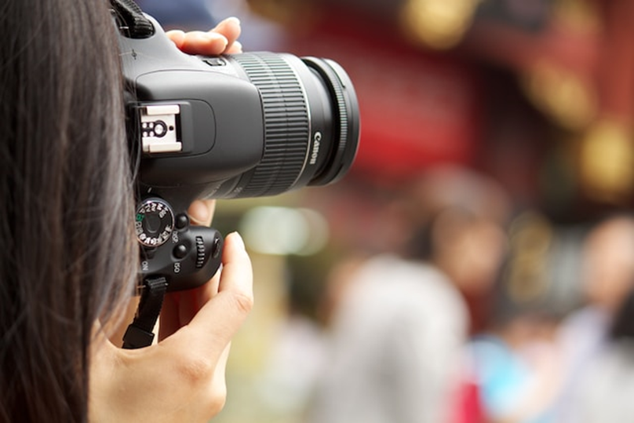
Media Famil Itinerary Example #3

ITINERARY – [YOUR EVENT]
[Date]

HOST CONTACT DURING STAY:
[Name; phone number]

[Date of first day]

TIME | LOCATION | DETAILS
10.00am | Location name  Address  P:  W:  Contact: [Name and position] | Meet [Name] from the [Your Event] organizing committee for a welcome and photo.
10.30am | [Your Town] Visitor Information Centre  Approx 7 mins drive  Address  P:  W:  Contact: [Name and position] | Meet [Name/s] at the Visitor Information Centre who will provide you with a media kit and provide you with an overview of the region’s attractions.
11.15am | [Your Town] Museum  Approx 1 min walk from the Visitor Centre  Address  P:  W:  Contact: [Name and position]  FOC: entry to the museum, courtesy of the museum | [Description of the museum]
12.45pm | [Name of restaurant]  Approx 5 mins drive from the museum  Address  P:  W:  Contact: [Name and position]  FOC: Lunch for one courtesy of the restaurant | Enjoy lunch at the [name of restaurant]. [Description of the restaurant.]
2.00pm | [Name of accommodation]  Approx 5 mins drive from the restaurant  Address  P:  W:  Contact: [Name and position]  FOC: Overnight accommodation for one, courtesy of the hotel | Check into your hotel. [Add description of hotel.]  [Provide suggestions of where to explore before dinner e.g. where there are good opportunities for sunset images]
7.00pm | [Name of restaurant]  Approx 5 mins drive from the hotel  Address  P:  W:  Contact: [Name and position]  FOC: Dinner for one courtesy of the restaurant | [Description of the restaurant.]

[Date of second day]

TIME | LOCATION | DETAILS
8.00am | [Name of cafe]  Approx 5 mins walk from the hotel  Address  P:  W:  Contact: [Name and position]  FOC: Breakfast for one courtesy of the café | [Description of the cafe.]
9.00am | [Name of attraction]  Approx 20 mins drive from the cafe  Address  P:  W:  Contact: [Name and position] | [Description of the attraction.]
10.15am | [Name of attraction]  Approx 20 mins drive from the attraction  Address  P:  W:  Contact: [Name and position] | [Description of the attraction. E.g.: Travel to the beautiful hamlet of XXX. With award-winning food experiences, local merchant, art and craft shops, you can spend a few hours exploring the small town.]
12.00pm | [Name of cafe]  Approx 10 mins drive from the attraction  Address  P:  W:  Contact: [Name and position]  FOC: Lunch for one courtesy of the café | [Description of the cafe.]
2.00pm | [Name of bike hire company]  Approx 10 mins walk from the cafe  Address  P:  W:  Contact: [Name and position]  FOC: Bike hire courtesy of the hire company | Pick up your hire bikes from the [Name of hire company] and take a self-guided tour to [Name of destination], along the North Wall to Flat Rock and return. This is an easy ride and suitable for anyone with a moderate level of fitness. The hire company will provide maps and local information to help you along the way.  The ride (without stops) will take approx. 1 hour, however we recommend stopping at the [Name of lookout], Aboriginal Cultural Ways and experiencing the coastal recreational path along the way. If you need some hydration or a snack on the way back, stop in at the [Name of café]. Allow 2-2.5 hours with stops.
5.30pm | [Name of restaurant]  Approx 5 mins drive from the hotel  Address  P:  W:  Contact: [Name and position]  FOC: Dinner for one courtesy of the restaurant | [Description of the restaurant. E.g.: Dine on some of the region’s finest local produce in one of its most historic buildings. The multi award-winning hotel has been meticulously restored and serves modern Australian cuisine.]
7:00pm | Drive to airport for flight home

