Event Management
Toolkit
Website Design Checklist

Table of Contents
Table of Contents 1
WEBSITE DESIGN CHECKLIST 1
Basics 1
Selecting a website designer 2
Doing it yourself 2
Choosing your content management system 3
User Journey/Template 3
Structure, Layout & Navigation – Map out your design and content 4
Social Integrations & the Marketing Funnel 4
Must Have External Tools and Considerations 4
Search Engine Optimisation 4
Additional Tips 5

WEBSITE DESIGN CHECKLIST

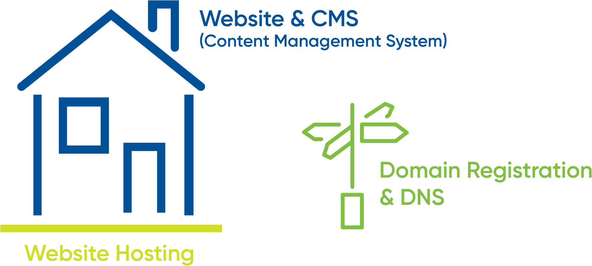
Basics
- If you think of your house being the Content Management System (CMS) of your website. The land it sits on is the website hosting. The signpost at the end of the street is your domain.
- Your domain – should be the first thing you get. “Yourdomain”.org.au (or .com.au or .com or .co). This can be registered anywhere eg. Netregistry, GoDaddy, VentraIP, Digital Pacific.
- Your CMS is the system your website is built on that also lets you log in and make changes, such as publishing, editing, managing and deleting content. The most popular CMS systems used are Wordpress (50.8%), Joomla (5.9%), Drupal (5.1%), Magento (4.5%), Shopify (2.8%), Squarespace (2.1%) and Wix (2.0%) (market share). Whilst Wordpress has been the most common system used in the past, there has been a big increase in other CMS systems geared towards DIY and ease of use, ecommerce and other features. In 2018 Wordpress, Shopify and Squarespace are the fastest growing popular CMS.
- Your website hosting. Some CMS use inbuilt website hosting. Open source platforms you will be required to purchase hosting in addition to your domain.
- Your email hosting. Separate from your website hosting. This can be via your domain registrant or via Google G Suite or Microsoft 365.
- SEO – Search engine optimisation – getting your website to rank as high as possible for relevant key words and phrases on search engines such as Google and Bing. More tips to follow.

Selecting a website designer
- When building a website, you will need to have an ongoing relationship with your designer/developer. This can mean everything from technical support to content updates and upgrades as time goes by. Ensure you find a designer who you trust, who you know can turn things around quickly for you, and who will be proactive about giving you ideas and a heads up as design trends and technology algorithms change. It’s important to know why Google may no longer be ranking your website and what is needed to fix this, before it happens!
- Websites can be expensive to maintain, and it’s important to know how much of the ongoing ‘servicing’ you will be doing yourself, and ensuring that your website is built using a system you can access and use comfortably. Some content management systems are easier than others to use, and if you feel like your team or committee will be doing most of the updates ongoing, make sure you choose a content management system which will be the most user friendly (See notes on CMS to follow). WYSIWYG (What you see is what you get) style website builders are best as you can see how a page will look as you build it.

Doing it yourself
- If you decide not to use a developer, there are a great range of tools out there to help you get a great website up and running. Wix, Weebly and Squarespace are excellent DIY tools. Canva can help you create engaging backgrounds, graphics and banners. - Note these tools do make it easy for anyone to build a website, but be aware that there is a difference between building a website versus building a website that works. If you decide to build your own, ensure you do some reading about user journeys, search engine optimisation and digital marketing basics before you choose this method.

Choosing your content management system
- Wordpress, Drupal and Joomla are all classified as open-source CMS. This means that the CMS code is freely available for people to modify, create additional functionality and widgets for. Closed source (or commercial/proprietary) systems like Squarespace, Shopify and Wix have their own internal functionality upgrades and app stores where the development, quality control and security is maintained internally. Both open-source and closed systems have different advantages and disadvantages.
- Open Source – Benefits – no licenses, free modules and plugins, thousands of templates, ability to move between CMS. Cons – quality of templates, little technical support means you will pay an ongoing developer for many minor updates and fixes, security and cracks for hacking.
- Closed Systems – Benefits – all technical upgrades, security issues, bug fixes are included and taken care of. Few if any examples of closed systems being hacked. Great designs, 24/7 support, updated automatically for latest design and technology trends to ensure you remain optimised for search engines, many easier to use and make updates. Cons – some limitations to complex functionality (limited to developed and developing modules), some say cost based on the added value provided.
- From a custom-built coded system to your simple DIY systems and everything in between, choosing your CMS can be the biggest decision.
  - Custom coded – ideal when you have unique and complex requirements, or a large site (over 100 pages). Custom developed websites will cost from $5000 to $100,000+ depending on the scope and what is required
  - Open Source – eg. Joomla, Wordpress, Drupal – an open source platform is usually free (although you will need to pay for your hosting). It may also cost you in other ways, for example ongoing security maintenance and updates. Whilst open source gives you access to hundreds of thousands of ‘widgets’ and ‘plugins’ if these aren’t maintained and updated over time, they can create cracks in your website which make it vulnerable to hackers trying to spread malware. If your website gets hacked, it is an expensive process to get a new site up and running and back on Google’s search results.
  - Closed systems aka Shopify, Wix, Squarespace – these have the ability to build excellent websites with fantastic functionality. Some have additional App stores, and you can also use external resources and Zapier to extend the functionality of your site. Although some of these are classified as DIY systems, many website developers can build your website on these platforms which will give you the ease of maintaining these ongoing.

User Journey/Template
- A great source of information to guide you can come from other sites. Do your research to look at other websites and figure out what you like from a design perspective and a functionality source. Are there any features you like? Start making a list.
- With up to 80% of web traffic coming from mobile in some categories, ensure your CMS/Template has a mobile friendly version. Essentially this means that, during your initial sketching and planning phase on paper, it is best to focus first on the site’s mobile layout. Only the most important content necessary to the functioning of your site will be displayed on smaller screens. This forces you to simplify your layout and cut out any distracting elements right from the start. Think back to your “above the fold” content: if you first ensure that all the important
- information can fit on the initial screen of a phone, then you’ll know for certain it will fit on larger screens. Once you’ve nailed the essential mobile layout, then you can begin adding in embellishments or larger images for desktop screens.
- Your mobile layout assumes a more vertical design that inspires scrolling, rather than the wide landscape of a desktop. If, say, your product page displays listings in a grid of 3 across on desktops, then usually your mobile layout will display them as just a single column.

Structure, Layout & Navigation – Map out your design and content
- The first step of website design often begins with the structure. Again look at existing sites to work out what tabs you will need across the top, what buttons and banners and calls to action
- Most event websites will have home, about, program, tickets, get involved / volunteer, destination information, contact
- Add navigation basics
- Tell us where your destination is
- Provide info to address niche interests
- Avoid information overwhelm
- Build your website to be social, use user-generated content if you can
- Give them ideas for what else to do in your region
- Link to complementary destination and tourism sites for your region.

Social Integrations & the Marketing Funnel
- What are your ultimate goals? Sell tickets, book accommodation packages, download programs, sign up for newsletters. Figure out the key things you want people to be doing on your website and gear it towards these outcomes. If you want people to sign up for a newsletter show them the types of blogs and content and value they will receive from it

Must Have External Tools and Considerations
- Google Search Console – register your site so that Google can crawl it, submit a sitemap
- Google Analytics
- Mailchimp Signup form
- Ticket Sales via Trybooking, Eventbrite etc.

Search Engine Optimisation
- Google Loves:
  - Sites with lots of words and text. The more text, the more Google can recognise your site as relevant for key topics. Avoid chunks of text as images or PDFs, transcribe or copy them into your content
  - Key words. Important but not the be all and end all. Remember to use key words which people will be searching in your text, but
  - don’t write your text to be too key word heavy. Use these in your page titles and H1 and H2 content
  - SSL Security certificate
  - Blogging – Google loves new fresh content, they hate websites which remain stagnant for too long
  - Avoid heavy files. Whilst big photo and video banners and full screen imagery are all the rage, they can make your site heavy and slow. Google hates this. Make sure your images are resized at the correct resolution for web. Use a website speed test to check this
  - Content is king, backlinks are queen, and video may be the spawn of the two. Google integrates video into Google Maps listings. So,
  - if you don’t have a video strategy, start developing one soon
  - Backlinks – External links are links from websites other than your own. Google relies heavily on external links to determine how good a website is. You can talk about yourself and your own skills all day long, but no one will believe you. But as soon as other people begin bragging about you, others take notice. The more referrals you can get from websites with high domain authority, the better. Eg. If Visit Australia points to your URL, Google will believe you are credible
  - Alt-tags for images – these tell Google what is in your images
  - Submit a sitemap to Google for indexing
  - Connect all of your social media
  - Use tools such as www.seoptimer.com for more tips.

Additional Tips
- A website doesn’t need to be 100% complete before you go live. It just has to be better than your current site. In our view a website is never actually complete as it will continue to evolve as your event evolves and as you begin to receive user feedback and iron out the wrinkles of your site
- Design trends and technological goalposts are constantly changing. A brand new website can look outdated within 12 months, and Google’s algorithm is changing constantly. When you invest in a website today, ensure it is robust enough to adapt as these things change. What happens if a new social media is announced tomorrow and you need it integrated? Eg. SSL security certificates and Mobile responsive design. Video banner trends. These are the sorts of questions to ask your developer. Are you up for a new development fee to change the structure and template of your site?
- Measure and tweak. Google analytics will give you fantastic insights into where people are coming from, what they’re looking at. If your popular content is hidden three clicks into the website, bring it to the home page as a prominent button. If more people are visiting from mobile, ensure your mobile experience is fantastic. Use other tools such as Hotjar heatmaps to see where people are scrolling and what they’re clicking on. You can also see the journey people take through a site and where they are dropping off
- Stock photos are your friend. Lacking imagery to get your website going? Use stock images. These can be replaced over time as you gain more relevant and real imagery. Free stock image sites:
  - Flickr
  - Pixabay
  - Albumarium
  - Magdeleine
  - Unsplash
  - Barnimages
  - NegativeSpace
  - Pexels
  - Skitterphoto
  - Jay Mantri
  - Polar Fox
  - Good Stock Photos
  - KaboomPics
  - Gratisography
  - Death to the Stock Photo
  - Pic Jumbo
  - Burst
- Avoid going too image heavy on your site with extraneous photos just because they may look nice. Instead, think of how each image you use serves its own purpose, and more importantly how it acts as content. A well-chosen photo can convey your brand, service, product, or audience much more effectively than words. Use photos to help your users understand something, to evoke emotion, or to inspire trust and confidence; using them purely for aesthetic reasons should be secondary
- Instagram feeds are a great way of keeping a homepage fresh with new content without having to constantly update it yourself.
- Use a push pull marketing strategy. House your content on your website, push it out via social media in an effort to pull people back to your website for more information, where they are one click away for signing up or making a booking
- Don’t leave it to the last minute. Building an online presence and recognition by Google can take time. Waiting for Google’s bots to crawl your website and begin listing it. If you are launching a new site, ensure your URL is updated on the Tourism Data Warehouse, and across all of your digital listings such as social media and Google My Business
- How often should you blog? As often as you can. Create a plan and divvy it out. Approach guest bloggers, local personalities, or complementary businesses or events. Share the load. One you’ve posted the content to your site, repurpose it in as many places as you can as a teaser – driving people back to the website for more
- Plan it out – When you first start the web building process try to have as clear an idea of what you want as you can. Look at other sites, mock up a map of your site, work out what content needs to be included, then go to your designer to start building. Understandably you may not know what is and isn’t going to work until it is in the site, you will still need to make some changes. If you go in with no clear plan and make constant changes, then process can take a long time, which could increase the cost of the website, or you might end up with a website that is incoherent and doesn’t have a good flow
- Keep it simple - It is often said that the best web design goes unnoticed; it is only poor design that calls attention to itself. As mentioned earlier, the most important aspect of any website is simply its text. If you can provide outstanding typography that is a joy to read, chances are you won’t need to do a whole lot more. Attempting to overdesign your site will just clutter and complicate things. Are the box shadows necessary? The crazy, ornate patterns? The dozens of colours? Probably not
- “The Fold” This is the initial page of information when someone lands on your page things that are above the fold are the first things you see, as such should be the most important things you see. Information here should be clear and simple and lead and give you reason to go to other areas that contain the bulk of your information. It is also important to have this area be visually appealing, it will be the first part of the page that your visitor will see and needs to give them a reason to keep looking. Great hero images are your friends here
- Following on from this, you need to get to the point on your website, visitors will not hang around if you do not give them a reason to. It is important that the message that you are trying to convey is front and centre. Promoting a brand? Make sure that it is clear what the brand is and what it represents. Promoting an event or location? Make sure that visitors know straight away where and what that event or location is, and why they should visit. If Visitors need to search your website for this information then the website is ineffective
- If you have any kind of interactive component on your website, be it a store, a registration or sign up page then it needs to be easily usable by visitors and easy to find. Visitors will be dissuaded if they need to go searching for a convoluted shopping cart, or if they need to fill out pages of information to register for your event
- Creating urgency is a great way to push visitors to register/sign up or purchase what you have on your site. Things like countdown clocks can help persuade a visitor to buy or book today, rather than leave it to the last minute when they could potentially forget
- Use effective social media and content that can be shared and that visitors want to share. If things go “viral” then that is free publicity bringing more visitors to your page. Things like, unusually stunning location pictures & videos, valuable information, fun polls & quizzes, creative designs for announcements, etc potentially could be shared amongst your users, bringing people to your site
- Make it easy for visitors to communicate with you, chat boxes, forms, easy to access phone numbers and email addresses mean that visitors can ask questions and get answers using their preferred communication methods, which could help them make a decision.

