Event Management
Toolkit

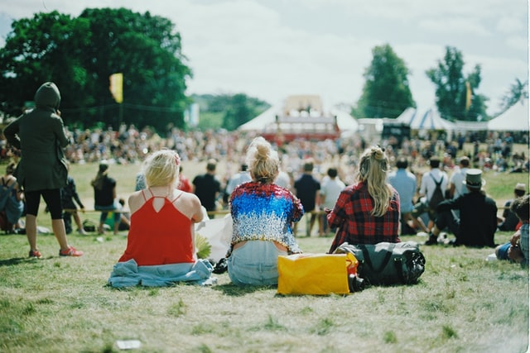
Post Event Review Checklist

SITE CLEANUP
- Arrange site clean-up, rubbish removal, dismantling and removal of hire equipment, return display material to sponsors.

PACK UP AND REPAIR SIGNAGE AND EQUIPMENT (all in order and easy to find next year).

MERCHANDISE
- Collate report of leftover stock; determine and record what sold best, when was the bestselling time, and what did not sell well. File this for next year.

ENGAGE AND INTERACT ON SOCIAL MEDIA
- Thank you posts to sponsors and volunteers
- Photo gallery wrap up (ask visitors to tag themselves)
- Blog of how successful the event was
- Share news articles on the festival
- Ask your stakeholders to write about the event (to generate additional content, improve SEO, and further promote the event to their networks)
- Leverage competition prizes by publicising the prize and the winner
- Keep listening for feedback and engagement
- Schedule some future cross-promotional posts.

IF POSSIBLE, START PRE-SELLING YOUR NEXT FESTIVAL
- Offer early bird discounts to get those tickets moving!
- Email a “Save The Date” to your database and stakeholders (such as stallholders who might want to return next year).

WRITE A FESTIVAL WRAP UP
- Media release, blog, newsletter, social media post. This will also help the community understand the value of the festival. Promote the success of the festival!
HOST A THANK YOU EVENT (for volunteers and other stakeholders).
SEND SURVEYS
- To visitors, volunteers, sponsors, stallholders, performers, and committee to get feedback and market research data.

SEND THANK-YOU MESSAGES
- To volunteers, sponsors, partners, funders, performers, committee, celebrities, and key stakeholders.

WEBSITE
- Add an event photo gallery
- Make any changes to the site so it is generic for the upcoming year
- Add the new date for next year
- Update third party websites.

FINANCES
- After the bills are paid, sit down with your original event budget to evaluate actuals against budgeted figures. Identify which areas did not meet targets and which stayed under
- Balance budgets and invoices
- Write acquittal reports for grants
- Prepare financial report.
DEBRIEF WITH YOUR COMMITTEE
- Celebrate the victories and fix the glaring problems constructively and positively: here the event stakeholders can discuss what worked, what didn’t, why it did not work and how it could be improved. The debrief meeting should aim to answer the following evaluation points:

  - Were goals and objectives fulfilled?
  - Were attendance targets met?
  - Can you identify aspects of the event that worked best?
  - Can you Identify anything that should be revised before a repeat event?
  - Did outsourced services, including materials used (i.e., caterers, security, decorations etc) meet expectations?
  - What services would you consider using again?
  - Did staffing/volunteers meet needs?
  - Did the event receive positive feedback?
  - Was the event worthwhile in relation to the scope of organisation needed?
  - Were budgetary targets (income and expenditure) met?

- Did sponsors and stakeholders get the outcomes they wanted?

- Have each committee member responsible for a certain element of the festival provide this information for their element:

  - What was successful or worked well
  - What was not successful or did not work well
  - Recommendations for the element
  - Recommendations for the whole event.

- If necessary, debrief with subcontractors e.g., traffic management, SES, DMR, paramedics, sound technicians etc, to learn what needs to be improved. (Refer to the Debrief Meeting Agenda Template).

GATHER FEEDBACK FROM AS MANY AVENUES/SOURCES AS POSSIBLE
- Post on social media a thank you message and encourage feedback from visitors, stakeholders, etc. Ensure you monitor this and respond to all feedback [Do not be afraid of criticism – it is a great opportunity to address it in a public forum]
- Meet all sponsors and ask for feedback on the partnership and the event. Aim to meet larger sponsors face to face and call the rest.
- Book and facilitate the committee debrief session
- Book and facilitate a wider community meeting for general feedback
- Collate visitor feedback and summarise, in preparation for debrief meeting
- Review digital platforms for feedback [Facebook, Trip Advisor, Google Search]
- Collate all news and media clippings about the event
- Gather feedback from all suppliers [hire company, stallholders, special guests, audio, etc]
- Touch base with funding bodies and source feedback
- Book a debrief meeting with council [if appropriate] to discuss compliance, site and general feedback.

PREPARE FESTIVAL REPORT
- To provide to sponsors, funders and committee. Include responses and analysis of surveys, and responses from debrief meeting/s.

Event Assessment:
- Number of spectators and residence
- Number of competitors and residence
- Number of exhibitors
- Gate takings
- Number of programs distributed
- Food, beverage, and other stallholder revenue/patronage estimates
- Number of vehicles/traffic management, including car parking
- Number of ‘hits’ on the event website
- Ticket sales processed through the event website (if relevant).

Estimate attendance:
Hopefully, you have ticket sales data or a counter to provide exact visitor numbers. However, if you need to estimate attendance, do not over-estimate but seek estimates from several different sources, particularly anyone with experience in special events such as stallholders and police. By obtaining estimates from different sources, a range, e.g. 5,000 - 6,000, should be able to be determined.
Business Activity Assessment:
Look beyond the event to the economic benefit gained by local businesses. Contact accommodations and other key businesses to obtain the following information:
- Accommodation bookings
- Airline/coach/rail bookings
- Restaurant and fast-food sales trends
- Taxi usage and revenue trends
- Retail sales trends.
Most of the business activity criteria are based on trends because businesses are likely to be reluctant to provide actual revenue details. However, by asking relevant operators the following questions, a pattern will usually emerge without infringing confidentiality:
- Did the operator experience an increase in patronage and revenue during the event?
- If so, by what percentage?
- How did this compare with last year’s event?
[Available: ‘Economic Evaluation of Special Events: A Practitioner’s Guide,’ by Leo Jago and Larry Dwyer at www.crctourism.com.au]
(Refer to the Post Event Report templates)
UPDATE FESTIVAL DOCUMENTS
- With improvements e.g. event management plan, timelines, position descriptions, asset register etc.
BOOK FESTIVAL SITE FOR NEXT YEAR (and anything else that needs to be booked now)

NOTES:

