Event Management
Toolkit
How To Use the Sponsorship Tracker

Table of Contents
USING THE EXCEL SPONSORSHIP TRACKER SPREADSHEET 3
SPREADSHEET 1 3
SPONSORSHIP WISHLIST 3
SPREADSHEET 2 4
SPONSORSHIP HIT LIST 4
SPREADSHEET 3 4
CONFIRMED 4
SPREADSHEET 4 5
BENEFITS TRACKING 5
SPREADSHEET 5 5
MARKETING TRACKING 5
SPREADSHEET 6 5
DECLINED 5

USING THE EXCEL SPONSORSHIP TRACKER SPREADSHEET

SPREADSHEET 1

SPONSORSHIP WISHLIST
Example
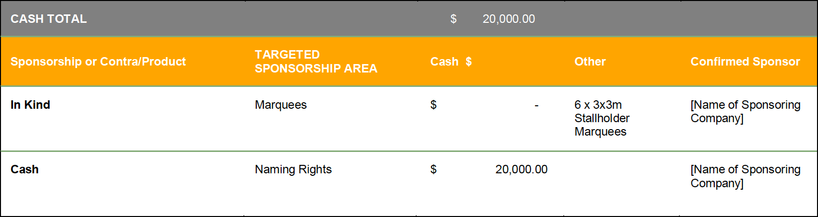

The Sponsorship Wishlist spreadsheet is an overview of what support (cash or in-kind) you need from sponsors for your event.
Ask yourself two main questions:
- How much cash support do I need?
- What items, products or in-kind support do I need, or would I like for my event to be successful?
- Once you know those things this spreadsheet is your plan for how you are going to achieve what you need.
Say for example you need $80,000 cash support. What areas of your event can a potential sponsor align themselves with to give them beneficial exposure? For example, naming rights to the event as a whole could be valued at $20,000. Even a smaller segment of your event (like camping area or parking area) can provide a sponsor with an opportunity to directly promote themselves to a mutual target market. Cost the area according to the value of its exposure for a sponsor.
This spreadsheet is an overview of what you need and your plan to get it.

SPREADSHEET 2

SPONSORSHIP HIT LIST
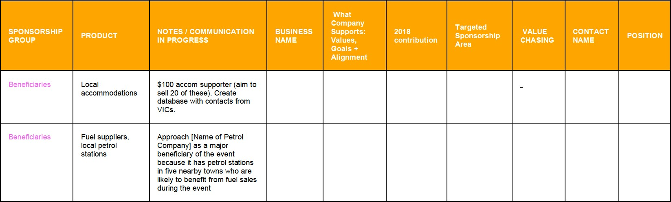
EXAMPLE

The Sponsorship Hit List spreadsheet is an overview of WHO you are going to try contacting to provide sponsorship of your event.
Ask yourself two main questions:
- What sponsors have similar values, goals or can align themselves with the brand of my event?
- What potential sponsors would benefit from promoting themselves to my target market?
Think big, think outside the box and start filling out this spreadsheet with absolutely everyone you can think of. Research contact details, names of who best to contact and highlight why this potential sponsor could be great to have on board!
Use the drop-down arrows to sort your data any way you like, by business name alphabetically, or by the notes you have written, (notes should be updated regularly and include updates on where you are up to with your communication), and even what area of sponsorship you are aiming to target them for.

SPREADSHEET 3

CONFIRMED
Once a sponsor is confirmed, cut their details from the Sponsorship Hit List sheet and move them in here. This spreadsheet becomes your “one stop shop” to view all your confirmed sponsors at any time.

SPREADSHEET 4

BENEFITS TRACKING
All your confirmed sponsors will have a list of benefits that you have mutually agreed upon in exchange for the cash or in-kind support that they will provide to you.
Use this spreadsheet to keep tabs on what you have promised them, and when you have delivered it.

SPREADSHEET 5

MARKETING TRACKING
All your confirmed sponsors will have a list of marketing benefits that you have agreed to give them in exchange for the cash or in-kind support that they agree to provide.
Keep tabs on what you have promised them in this spreadsheet.
It gives you the option to outline all benefits such as Facebook posts, Instagram posts, ad space in your program, etc. Use this spreadsheet to remind you of the URL addresses and dates posts and copy were completed.

SPREADSHEET 6

DECLINED
When a business declines your sponsorship invitation, cut their details from the Sponsorship Hit List spreadsheet and move them in here. Include a reason why – this is useful data for your post event reporting.
There are a number of licenses event committees need to organise in the months prior to an event.

