Women’s Honour Roll 2019

Recipients:
- Donna Cooper
- Caelli Greenbank
- Margret Lockwood
- Kathleen Morrison
- Rozanne Moynihan (Posthumous)

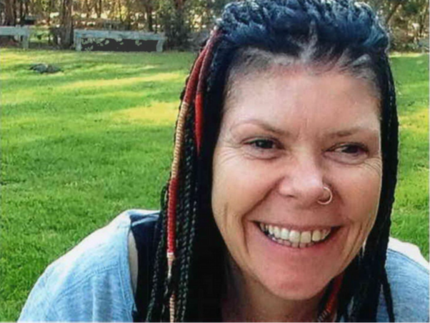
Donna Cooper
“Donna is the most strong and passionate women that I know, who shares so much love for her store and all her beautiful people in Cambodia”

Donna Cooper is an extraordinary woman who has dedicated her life to working with other girls, women and their communities in order to empower them, educate them and inspire them to make their dreams come true.

She has overcome a difficult childhood to become a successful and compassionate mother and business woman. Starting “Colour Me Cooper” in Daylesford as a preloved clothing store, it has now developed into a beautiful, eclectic store stocking handmade fair trade ethical clothing. A large percentage of the profit from the store goes back to communities in Cambodia and Donna employs local women, inspiring them and teaching them integrity, caring for the broader world and leadership.

Donna has changed the lives of hundreds of Cambodian women and their families through the installation of wells for clean water in Kampong Thom, leading to improvements in sanitation, vegetable gardens and a cleaner environment. From these initial endeavours Donna and her daughter Sam started The Cambodian Kids Foundation (CKF) which works at the grass roots to educate and empower women. One resulting project is a free public school in Kampong Thom. Donna also provides an opportunity for Australian students to visit and immerse themselves in the day to day activities of the village, a
transforming experience.

She has also created the “Sew Good Company” giving Cambodian women the opportunity to make lovely clothes that are sold to 55 outlets in Australia and “ONE Day Spa” in Phnom Penh providing a beautiful and safe working space for employees who all receive income plus other benefits.
Donna has overcome early hardships and gone on to accomplish much both personally and professionally, inspiring other women to do the same.

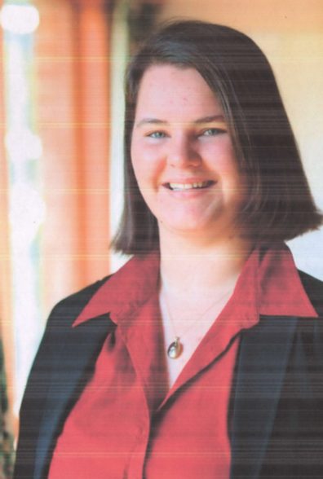
Caelli Greenbank
“The voyage (on the Young Endeavour) proved to be one of the most challenging experiences of her life, physically, mentally and emotionally.”

For the past 20 years Caelli has been a prominent and active young citizen of the Creswick community, is passionate about a wide variety of local organisations and has distinguished herself in Australia and abroad.

In 2006, while at school, Caelli was selected as one of 10 winners of the Victorian Premiers Spirit of ANZAC Prize and joined a two week study tour to Turkey and the Western Front. On her return she was invited to speak to local schools and the community, culminating in speaking at the Creswick ANZAC Day Service in 2008, being named Hepburn Shire Young Citizen for 2008, and becoming an ANZAC Centenary Ambassador for Victoria. This interest in the ANZAC’s also resulted in her personal project of photographing the 25 WW1 Soldiers listed on the Creswick Cenotaph, and their exhibition in 2018 at Creswick Museum.

At the age of 17 Caelli was awarded an Order of Australia Medallion for “demonstrating the ethos of the Young Endeavour Youth Scheme” after undertaking the gruelling 11 day voyage on Australia’s sail training vessel Young Endeavour. She has been volunteering aboard Melbourne’s tall ship Enterprise since then, becoming a respected team member and acting as an ambassador for the Young Endeavour Youth Scheme.

During her university years she was involved in Student Representative groups and Cycling Victoria and was recognised as a leader in all roles she undertook. She has a long and successful history of Girl Guiding and involvement in Community Theatre.

In all areas of her life Caelli has continued to strive for excellence and her successes have paved the way for other women, especially in the fields of sail training and cycling. She stands as an inspiring role model for young women.

Margret Lockwood

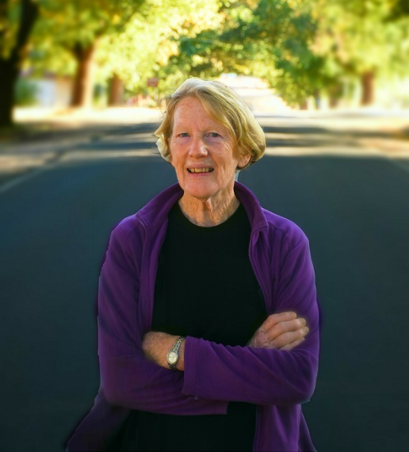
“Throughout she has been a quiet and determined leader, engaging and encouraging young and old to be involved”

Margret is a very visible community hero and untiring contributor to her community. She seems to be everywhere and has created long term sustainable change across a number of organisations.

Winning a scholarship to finish her education she went to University where she was active in feminist issues and went on to become a secondary teacher. She says her greatest achievement was from 1988 to 2000 in Wangaratta and Daylesford where she combined teaching with being student welfare co-ordinator. She was described as awesome by some of her past students.

Her greatest challenge was the death of her husband in 2008. Her loss of purpose and meaning and then her ability to talk about this with other women has helped many. She also learnt the importance of community and determined to leave a legacy that would give meaning to the rest of her life and which has framed her past 10 years.

Margret developed a strong commitment to the CFA, taking on the Communications Officer’s role in the Glenlyon Brigade, a role her husband previously held. She co-authored the centenary history of the Glenlyon brigade, organised centenary celebrations, maintain the gardens and surrounds, and is an active advocate for women firefighters. She is now Glenlyon Group Training officer and has been active in development of a District Women’s Reference Group looking to motivate and support women in firefighting in the broader district.

Her passion for gardening has led to an active involvement in Landcare and she had been on the Executive of the Upper Loddon Landcare Group for 10 years with a specific interest in improving access, treed areas and historical information for the Loddon River and Loddon Falls.
Margret is a wonderful role model and demonstrates constantly her commitment to advancing women’s status.

Kathleen Morrison
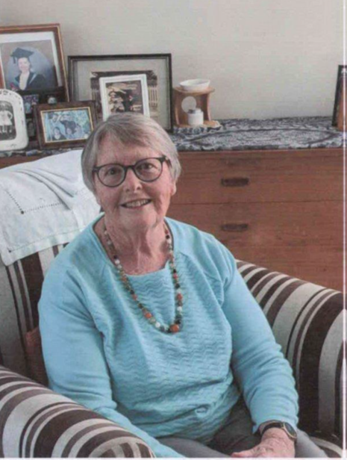
“My own circumstances enabled me to empathise with the issues faced by other women and to help them deal with their own life challenges”

Kath was born in Trentham, delivered by Dr Gwen Wisewould and went to school in the area. She admits that she battled a range of issues relating to the traditional male/female norms of the day, however during difficult times never lost focus on her responsibilities towards her four children.

She has been serving, caring for and being an inspiration to the women in the Hepburn Shire for nearly 65 years. At 15 she joined The District Girl Guides movement, rising to be a District Leader and it was not uncommon for 20 or more adolescent girls to have a sleepover in her lounge, giving her an opportunity to pass on her skills and wisdom. She is proud of the women they have become.

She delivered meals for 12 years. She delivered mail and if residents needed help or were simply lonely they tied a plastic bag to the letter box and Kath would return later. “I never say No, especially when the request comes from someone in need”.

At 60 she fulfilled a dream and studied Aged Care and subsequently working for 12 years in Daylesford and Trentham. One of her most impactful initiatives was to introduce “High Tea’ accompanied by music performed by the Walsh’s.

Kath has been an important member of a number of other community groups including the Tylden Cemetery Trust, the Trentham Neighbourhood Centre, and The Trentham Historical Society and has been an active member of local choirs. She was also President of the St Mary Magdalen Guild and Op shop.
Kath is an unassuming person whose purpose in life has been to ensure that women achieve their potential and overcome personal difficulties. She has learnt to become independent and resourceful. She is an unsung hero.

Rozanne Moynihan (posthumous)
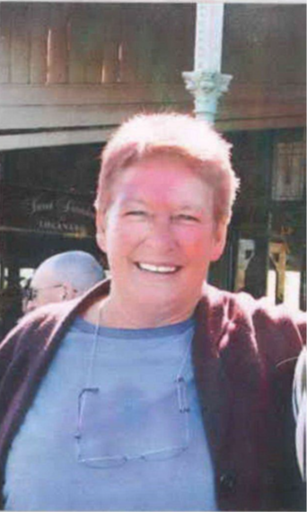
‘Roz was always such a giving lady, she always did everything to help others in need. Roz inspired me to do the same”.

Roz has created sustainable change in the lives of the many whom she touched intentionally through her mentoring, caring and mothering roles pursued over many years.

She was “gender blind” seeing no reason why a woman could not do whatever she wished. She was a Life Member of Daylesford Speedway both as a driver and volunteer, was the first woman coach of the Under 8 Soccer team and refused an invitation to join the RSL until she was made a full member.

She held positions of leadership in all the committees and organisations she joined. She was a Life Member of Chillout and President, Secretary, and on Fundraising Committees in the various other organisations she was involved in – the Inner Wheel Club, RSL, and Scouts to name a few. The local Rotary Club awarded her the Paul Harris Fellowship (2013) paying tribute to her contribution to the community even though she wasn’t a Rotarian.

She was an uncompromising supporter and mentor of many young girls through for example the Primary School Remedial Parents programs, Scouts and the young soccer teams. A number of young women in our community have stated how important she was in their lives - “Roz took me, a feral teenage kid, into her family and treated me as one of her own in every possible way. She was the encouraging adult I needed in my life” and “when she looked you in the eye you could feel that she trusted you to be yourself – whatever that might be”.

There were over 700 at Roz’s funeral. She was called an icon of Daylesford. She certainly upheld and advanced the status of women through her lived experience.

