Women’s Honour Roll 2021

Recipients:
- Frances Fiddian
- Betty Johns
- Verena Doyle

FRANCES FIDDIAN

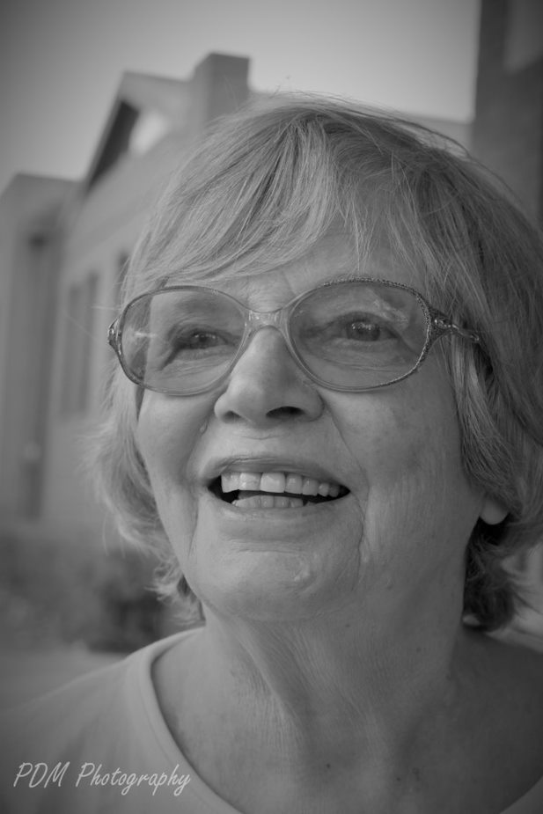
Over the past 50 years, Frances Fiddian has empowered women and supported them to successfully manage natural mothering, giving them the confidence and peace of mind that their babies were getting the very best in nutrition and care. In 1969, when Frances left hospital with her first born baby son, successfully breastfeeding. Her confidence evaporated when he cried between feeds and did not cope with the 4-hour feeding schedule which was the norm. It was suggested that Frances contact the Nursing Mothers Association of Australia (NMAA), she did and was given guidance and reassurance.

In those days, there was a strict regime of feeding times and a lack of understanding of the science of breastfeeding. Many new mothers were isolated in their homes, being unable to leave the house in case the baby needed feeding. The NMAA began as a self help group where experienced nursing mothers helped, encouraged, educated and supported other mothers wishing to breastfeed their babies. Frances own experience motivated her to volunteer to support other mothers, she began as an administration assistant and helped with fundraising, she was then promoted to Group Leader, organising personal contacts and visitations, distribution of NMAA newsletters and organising breastfeeding tutorials for 100 members.

Frances trained to be a Counsellor, qualifying in 1974, she began training new Counsellors, as demand was growing. In 1976, Frances met with other Counsellors and a roster system was set up, this was the first breastfeeding help line taking calls day and night. Frances was the Coordinator for two years, often the phone would ring at dinner time which meant Frances was super busy whilst caring for her own two young boys.

She joined the NMAA Executive committee in 1977, as Treasurer and became President in 1979, she remained on the board until 1983. Frances was interviewed several times by local Melbourne radio and TV, it took considerable courage to discuss breastfeeding when the very word was not publicly acceptable. Whilst sometimes feeling alittle apprehensive, Frances felt it was important to put the NMAA onto prime media to get the message out to mothers. It is estimated that 240,000 women has passed through the NMAA over the time of its operation. Throughout her involvement with NMAA, Frances shared of herself, her time, her knowledge and experiences helping new mothers to be confident, resilient and feel supported.

BETTY JOHNS

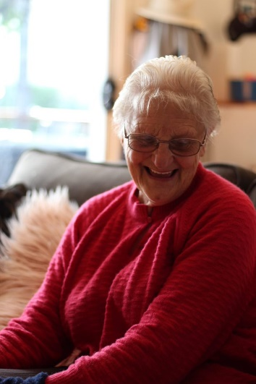
Born in 1931, Betty grew up in Old Hepburn and attended Hepburn State School. In 1949 Betty commenced training to become a Registered Nurse at the Daylesford Hospital and then spent a further 12 months at the Women’s Hospital in Melbourne.

Very few women trained for a profession in this era that was not only poorly paid but also required leaving home to train. There were also legal obstacles that forced women to stop working after marriage.

Following her marriage to Bryan in 1953 Betty had to leave her nursing career and the family bought their first home in 1956. When they lost their main source of income, and already with 6 children at home, Betty returned to nursing as the main income earner. Betty was somewhat of a trailblazer as this was 5 years before the marriage bar was lifted. While nursing Betty had another 8 children (one still born) and returned to work sporadically. Working and raising 13 children in an era without childcare or assistance demonstrates Betty’s ability to overcome any challenges and she modelled great work ethics and principles to her family and the wider community.

In 1980 Betty’s husband was diagnosed with terminal cancer and she nursed him at home until his passing in 1981. Betty continued to still run a household with 5 young children remaining at home. Being Betty withstood any social disapproval through her ability to balance a career and family. Although Betty was not on the front line of campaigns, she still challenged the norms in her own conservative way and demonstrated that a woman could be a successful wife, mother and worker.

Betty was our regions own shining example of how a working woman who raised well respected children meant that equal rights and pay did not corrupt social order. Betty has encouraged other woman that they can do anything and to be the change they want to see. Betty has more than proved that women are more than capable or working, raising a family and volunteering in their communities.

Betty has been involved with the local community for many years volunteering her time to support the Brass Band as their music collection Librarian even though she doesn’t play an instrument, coordinating the Blood Bank service for 12 years, MS Op Shop for 19 years including mentoring new volunteers, Hepburn Primary School where she sponsors an award in recognition of the education they provided her 13 children, Hepburn Football Netball Club, Anzac and Remembrance Day, Wombat Hill Botanic Gardens, “Afternoon Teas” to combat loneliness and depression, Love Your Sister Campaign and so much more.

Betty’s lives her life demonstrating dedication to her community, service above self and the importance of treating people with care, consideration, kindness and compassion. Betty’s determination to educate herself, provide for her family and her community showcase the importance of equality in society and she is an exemplary example to woman of all ages, that if you work hard and are resilient you can achieve anything.

VERENA DOYLE

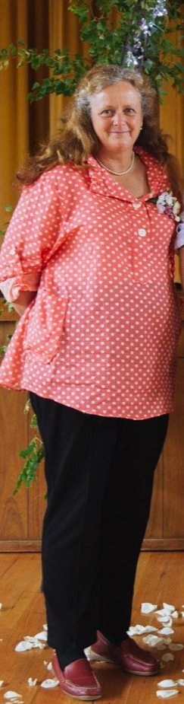
Verena has been inspirational in her work with Scouts Victoria and her volunteering at 1st Creswick Scouts has been beneficial for many young females in the local Creswick community. When Verena first began to volunteer at Creswick Scouts there were no girls in the local scout troop, only boys. This changed after Verena began to volunteer and encouraged girls to transfer from Girl Guides to Scouts. She believed that some girls would enjoy Scouting more as they weren’t interested in traditionally ‘girlish’ activities. She opened the way for girls to join what was often considered a ‘boys club’ and encouraged them to complete activities like kayaking, skateboarding and archery.

Verena set up the first Creswick Venturer Unit, which was the first all female Venturer unit until the first boy joined six months later. The first chairperson, treasurer and secretary were all female and this showed the other scouting units that it is possible for girls to lead themselves. The Venturer Unit at Creswick is still running today.

Within only a few years of Verena restarting the unit, Creswick Venturers celebrated, for the first time in 19 years, a Venturer achieving the Queens Scout Award. This was a highly significant event considering the unit was only newly formed and was only just starting to forge its own path. Her focus on supporting young Scouts to achieve their Queen Scout Award has also left a legacy of success in the local group and has given future Scouts a goal to work towards.
Verena excelled professionally, first completing a Bachelor of Nursing which led her to work at Daylesford Hospital. She then went on to study a Bachelor of Arts (Rural Social Welfare) with a Graduate Diploma in Chronic Condition Management. At this time she was working full time as a nurse at Creswick hospital with three kids at school.

She currently works at Mataranka Scout Camp in Goldsborough, the only Scout camp dedicated to environmentalism in Victoria, where she focuses on revegetating and rebuilding the camp for future Scouts to enjoy. Verena continues to attend almost every camp at Mataranka which has meant that girls from visiting Scout troops are able to attend to learn new skills as girls can only attend camps if there is a female leader present.

Verena who has a severe hearing impairment has spent much of her life overcoming difficulties and despite these challenges she has not only strived to do better for herself and her family but aimed to improve the lives and experiences of those around her and her community.

