Women’s Honour Roll 2018

Recipients:
- Annelise (Mara) Macs
- Rosemary Wilson
- Maureen Corbett
- Annie Smithers
- Bessie Harrison (Posthumous)

Annelise (Mara) Macs
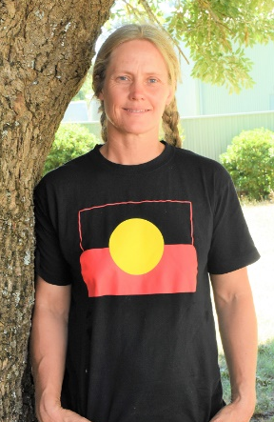
Has been teaching circus skills to children and adults of the Daylesford community for the past 20 years, having founded the Sprung Circus in 1996 she also coordinated the acquisition and donation of a substantial midwifery kit to the Balep Health Clinic, Ambryn Island, Vanuatu.

She gives her time freely to community events, such as parades and festivals because she passionately believes in community and because she loves people. The circus that Mara has created runs on the smell of an oily rag, but she insists on keeping her prices low so that they are affordable to all. Mara works many tireless and unpaid hours for the circus, creating shows, rehearsing with the children and creating props and costumes. In her classes all people are treated with care and respect and a healthy dynamic of celebrating one another is fostered.

Mara has supported, encouraged and empowered generations of girls and young women to know their own strength, revel in their bodies, learn to trust each other, and work together and enjoy in both the circus community and the wider community.

Mara helps shape the lives, attitudes, work ethic and perspective of many young women and people in the Hepburn Shire.

Rosemary Wilson
Rose's work with women started in East Arnhem Land where she spent a great deal of time with the indigenous women and children, hunting and gathering and teaching arts and crafts to the local school children. Also involved in the Community Health Clinic, Rose tutored the local women in communication, building confidence and self-esteem. On occasion she offered her home as a refuge for local women escaping domestic abuse. She also curated the Blue Stocking "WORKS BY WOMEN" in Darwin which is an annual event celebrating the importance and achievements of women in higher education where the proceeds go towards the prevention of domestic violence in small communities.
Rose worked for the Drug and Alcohol Rehabilitation Centre in Katherine, where she assisted and offered support to people living in public hostels and on the streets. In Vietnam, she volunteered with ERIGO and taught English to the poor and underprivileged children in the Mekong Delta.
In her home town of Trentham, Rose helped established an artist run gallery which exhibits and promotes local art and artists. Rose is also an award winning artist herself being a finalist in the Archibald, The Moran and The Black Swan. She recently founded the annual Dr. Gweneth Wisewould Portrait Prize held locally, which is in honour of Gweneth Wisewould, an unconventional doctor who worked on the divide at a time when women were not expected or even encouraged to have a profession.
Rose's recent exhibition " The Disappearing Farmer" which toured to the regional gallery in Albury and in Trentham, has been one of her most important and memorable achievements. This exhibition created a lot of interest and awareness of how important the small family farms are to this region and the integral role women play on the survival of these farms.
Rose has organised & donated many of her own art works for fundraising events including the CFA, Lyons Club, Hepburn Women's Health, Ovarian Cancer Research, local Schools and many other community groups around Trentham.

She was also an Ambassador for the Kyneton based NGO Artists for Orphans, a charity assisting victims of Agent Orange.

Maureen Corbett
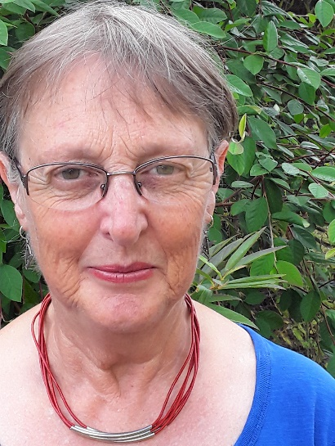
Maureen lived, worked and volunteered in the Hepburn Shire for 37 years. She has left a legacy of fine achievements in community organisations, both formal and informal. Recently she moved away but continues to keep in touch and foster links between her new community and the Hepburn Shire.

Maureen is a quiet, humble achiever, a mentor for women and a powerful and persistent agent for change, walking the talk, living her beliefs. As a long-term, consistent initiator, networker and motivator, she encourages and supports women of all ages to believe in themselves, so they too can work together to make a difference and build a better future. Maureen is the
kind of woman who creates the glue that knits a community together. By her lived example, she demonstrates how to be a community elder.
Maureen’s involvements in the community have been wide- ranging and numerous. To name just a few: she has had a pivotal role in the Hepburn Relocalisation Network, Spalets Local Exchange Trading Scheme, Hepburn Wind Farm start-up committee, Daylesford Neighbourhood House committee, Hepburn Primary School Council, the sustainability group, SHARE committee, and the start-up Child Care Centre committee. She has been a teacher, trainer and/or tutor in sustainability, solar house design, energy ratings and permaculture, as well as mathematics.

Maureen has been an early adopter of all things that make a resilient community and was first in line to help people make their households sustainable, through her partnership business “Solar Sisters”, and by running the first solar panel bulk buy scheme in the Hepburn Shire, which resulted in 35 systems being installed on local roof tops. As well, she modelled sustainability through the development of her property in Old Hepburn, including using low embodied energy materials in 4 owner-built projects.

Expecting fairness at all times, Maureen did not shy from challenging those in authority whenever there was evidence of gender inequality. As a maths teacher, she found several opportunities to speak out, at the risk of being marginalised as a ‘rabid feminist’. She has always encouraged and supported girls and women to reach their full potential. She found girls had a different way of relating to the hard facts of mathematics, that their confidence was more fragile, but that, with a small amount of encouragement, they could succeed. Thus, in many small, quiet ways Maureen helped to advance the status of women.

The examples of Maureen’s work outlined in her nomination show a different kind of leadership, a very female way of working and being effective in the world. We do not all seek to be the head person. Maureen’s method is inclusive and relational. Women more often work in a shared way and she has expressed that she wants her nomination to acknowledge the many women in the Hepburn Shire who have quietly (and not so quietly) worked together to initiate much needed social, political and environmental changes. She is an advocate for a more collaborative, collective, shared leadership, where all voices are heard and the value of all points of view is reflected in better, more sustainable outcomes.

We advance gender equity when we honour and value women’s skills equally with those of men. Maureen has modelled an alternative to the patriarchal style of leadership seen in most of our present, official structures. She has set up processes and support circles that empower women to create rich and meaningful, less consumption-oriented lifestyles, and build strong relationships and community resilience. In leading in this way, she has helped to raise the profile of women and the different way in which they often work.

Annie Smithers
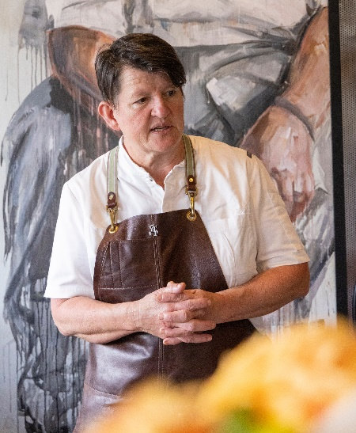
Annie Smithers credits her interest in and love of food and joy of cooking to her parents ——particularly her mother, an English Literature teacher, with excellent cooking skills and a fine intellect devoted to words and books —— Julia Child, Alice Waters and Simone Beck were prominent authors on their book shelves. And the luxurious dinner parties hosted by her parents also strongly feature in her childhood of the 70s on a small acreage in rural Victoria. From the age of 8 she only wanted to be a chef or a butcher.

She did her apprenticeship with Stephanie Alexander at Stephanie’s in Hawthorn, and Stephanie has remained a friend and mentor for some 30 years. They quickly bonded through their enthusiasm for fresh ingredients, French Farmhouse cooking and a love of handmade things. Stephanie remembers that one year she took up snail farming and the snails became Annie’s responsibility. It was a hideous job caring for them, but Annie approached it like it was interesting. She did it for hours and hours and did it very well.

After her apprenticeship, she worked in several Melbourne restaurants, before coming to Daylesford and The Lake House before finally settling with Carol White at Lavendula, who not only ignited her passion for gardening but the important concepts of space and design. So, Stephanie’s passion for cooking and Carol’s delight in and knowledge of gardening combined to be pivotal influences.

Annie’s philosophy is to cook for her guests in the style found throughout Europe, the simple set menu of 2 - 3 courses designed by the chef according to whatever is in season. 90% of the food she cooks comes from her own kitchen garden, and what doesn’t is locally sourced. Her food is designed to be shared, and to encourage guests to Iinger at the table in convivial groups.

The eye must also be engaged, so this beautiful, rustic, home-cooked food is served on ceramic platters, boards and copper sauteuses. She shares her keen sensual appreciation of food —- its shape, its colour and the story behind the dish. She has been known to bring a full tart to the table, so the diners, too, can enjoy the dish in its entirety. She has helped create a movement of people wanting to know where their food comes from. In her own words, “I realise I am absolutely living my dream, or at least my interpretation of it. The food is unashamedly French Farmhouse as its style of cooking, that has vast possibilities, yet a familiarity that is truly comforting”.

Bessie Harrison Lee (posthumous)
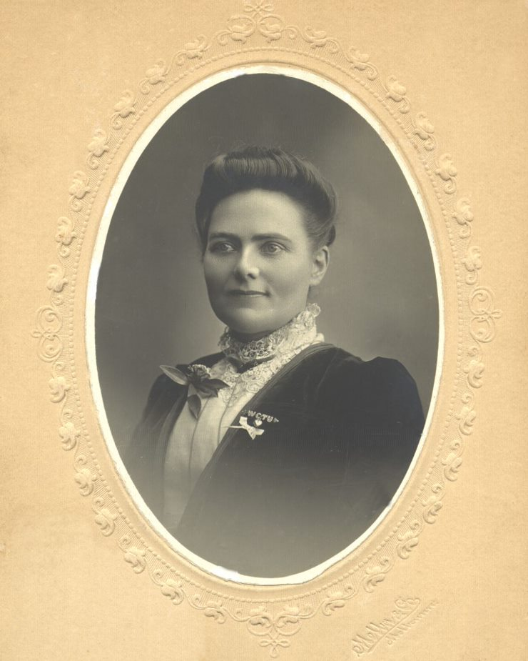
Bessie Harrison Lee, née Vickery and later known as Bessie Lee Cowie, was born in Daylesford in 1860. She had little formal education and suffered childhood abuse by alcoholic relatives in whose care she was entrusted after the death of her mother when she was only eight years old. Her childhood was lonely and isolated. But, despite these challenges, Bessie rose to become a world famous Temperance leader, suffragette, public speaker, writer and social reformer.

Although she left Daylesford as a young girl her memories of Daylesford had a profound effect upon her. Her mother is buried in the Daylesford cemetery.
From childhood, Bessie was creative, unique and innovative. These qualities continued into adulthood and were manifested in the way she spoke, wrote, thought and acted.

Bessie was a brave and influential woman who worked tirelessly for improving the lives of women in many areas of society. She saw first-hand on the goldfields, and later in the working class areas of Melbourne, the devastating physical and financial impacts that alcohol had on the lives of women and children.

Bessie became a member and leader of the ‘Women’s Christian Temperance Union’ (WCTU). The WCTU and affiliated Temperance organisations were strong and formidable advocates and campaigners for women's suffrage. In May 1891 Bessie was part of a powerful deputation of women to the Victorian Parliament pleading for women's right to vote. Her signature is the 6th on Victoria's famous Monster Women's Suffrage Petition. She was a tireless and passionate campaigner for women’s suffrage – writing and speaking prolifically on the subject. Bessie and her fellow suffragettes were the pioneers of gender equality.

Bessie travelled the world in her Temperance leadership roles. She was inspiring and drew large crowds wherever she spoke and captivated a cross section of the population.

As with alcohol, Bessie witnessed the devastating financial and physical impacts that large families and unwanted pregnancies had on the lives of women. She advocated that women should have sole right over their bodies and motherhood should be voluntary. These ideas were controversial and way ahead of their time. Her ideas and work have made her the subject of modern feminist academic research and writing.
Bessie remained an activist all her life and died in Pasadena USA in 1950.

